

Christ Nagar, Hullahalli, Begur - Koppa Road, Makiwara, Post, Bengaluru-560083

# DEPARTMENT OF COMPUTER SCIENCE AND APPLICATIONS

A PROJECT REPORT ON

**“SPARKLE CLEAN: ONLINE HOME CLEANING SERVICE BOOKING SYSTEM”**

*Submitted in the partial fulfilment for the award of degree in*

# BACHELOR OF COMPUTER APPLICATIONS

Submitted by

**JIXEN BIJU (ROLL NO: 209USB7020)**

Under the guidance of

## DR. SALMA FIRDOSE ASSISTANT PROFESSOR

**DEPARTMENT OF COMPUTER SCIENCE AND APPLICATIONS**

**JULY - 2023**



Christ Nagar, Hullahalli, Begur - Koppa Road, Makiwara, Post, Bengaluru-560083

# DEPARTMENT OF COMPUTER SCIENCE AND APPLICATIONS

Date:

**CERTIFICATE**

This is to certify that the project work entitled **“SPARKLE CLEAN:ONLINE HOME CLEANING SERVICE BOOKING PORTAL”** is a bonafide work done by **JIXEN BIJU (209USB7020)** of **6th Semester** in partial fulfilment of requirements for the award of the degree of **Bachelor of Computer Applications** at **CHRIST ACADEMY INSTITUTE FOR ADVANCED STUDIES** affiliated to

Bangalore University during the academic year 2022-2023. It has been found to be satisfactory and hereby approved for the submission.

Dr. Salma Firdose Dr. Sangeetha Govinda

**(Project Guide) (Head of the Department)**

### Examiners:

**1.**

**2. College Stamp**



Christ Nagar, Hullahalli, Begur - Koppa Road, Makiwara, Post, Bengaluru-560083

# DEPARTMENT OF COMPUTER SCIENCE AND APPLICATIONS

**Acknowledgement**

First, I would like to thank all the people who assisted me at **Christ Academy Institute for Advanced Studies** for the completion of my project with their patience.

It is indeed with a great sense of pleasure and immense sense of gratitude that I acknowledge the help of these individuals.

I am highly indebted to the Principal **Rev. Dr**. **Fr. Babu Paul** for the facilities provided to accomplish this project.

I thank **Prinston Smart Engineers** for providing the internship opportunity..

I would like to thank my Project Guide **Dr. Salma Firdose** and Department Head **Dr. Sangeetha Govinda** for her constructive criticism throughout my project.

I am extremely grateful to my department staff members and friends who helped me in successful completion of this project.

### JIXEN BIJU 209USB7020



Christ Nagar, Hullahalli, Begur - Koppa Road, Makiwara, Post, Bengaluru-560083

# DEPARTMENT OF COMPUTER SCIENCE AND APPLICATIONS

**DECLARATION**

This is to certify that the project report entitled “**SPARKLE CLEAN: ONLINE HOME CLEANING SERVICE BOOKING PORTAL”** is done by me, and it is authentic work carried out for the partial fulfilment of the requirements for the award of the degree of Bachelor of Computer Application (BCA) under the guidance of Dr. Salma Firdose. The matter and software embody in this project has not been submitted earlier for award of any degree or diploma to the best of my knowledge and believes.

### Date: Signature of Student

JIXEN BIJU 209USB7020



**INDEX**

|  |  |
| --- | --- |
| **TABLE OF CONTENTS** | **PG NO** |
| **1. INTRODUCTION** | 1  1  1  1  2  2  2  2 |
| 1.1. Project Description |
| 1.2. Problem Statement |
| 1.3. Existing System |
| 1.4. Limitations of Existing System |
| 1.5. Proposed System |
| 1.6. Objectives |
| 1.7. Benefits the Proposed System |
| **2. SYSTEM REQUIREMENTS** | 3 |
| 2.1 Hardware Specifications | 3 |
| 2.2 Software Specifications | 3 |
| 2.3 Tools Survey | 4-9 |
| **3. SYSTEM DESIGN** | 10 |
| 3**.**1 Modules | 10 |
| 3.2 Data Flow Diagram | 11-13 |
| * 1. E-R Diagram   2. Database Design | 14-17  18-19 |
| **4**. **CODING** | 20-109 |
| **5. IMPLEMENTATION** | 108 |
| 5.1 Screenshots | 108-123 |
| **6. TESTING** | 124 |
| 6.1 System Testing | 124 |
| 6.2 Integration Testing | 124 |
| * 1. Unit Testing   2. Test Cases | 125  125-135 |
| **7. CONCLUSION** | 136 |
| **8. FUTURE ENHANCEMENTS** | 137 |
| **9. REFERENCE** | 138 |

**SPARKLE CLEAN**

# HOME CLEANING SERVICE BOOKING PORYTAL

1. **INTRODUCTION**

Sparkle Clean is an innovative online platform designed to revolutionize the process of booking and managing home cleaning services. With the increasing demand for convenient and reliable cleaning services, Sparkle Clean provides a user-friendly web-based application that allows homeowners to easily book professional cleaning services for their homes.

## Project Description:

Sparkle Clean is a PHP and MySQL-based project developed to simplify the process of home cleaning service bookings. The platform offers a wide range of cleaning services tailored to the needs of homeowners. By leveraging technology, Sparkle Clean aims to enhance the overall cleanliness and hygiene standards of homes while providing a seamless user experience.

## Problem Statement:

Finding reliable and efficient home cleaning services can be a challenge for homeowners. The traditional process of searching for cleaning companies, making phone calls, and scheduling appointments can be time-consuming and cumbersome. There is a need for a convenient and efficient solution that streamlines the booking process and ensures reliable cleaning services.

## Existing System:

Currently, homeowners rely on traditional methods of searching for cleaning services, such as asking for recommendations from friends or searching through directories. This process often involves multiple phone calls, negotiations, and uncertainties regarding the quality and reliability of the cleaning services.

## Limitation of Existing System:

* **Not user friendly:** The present system is not friendly because data is not stored in structure and proper format.
* **Manual Control:** All report calculation is done manually so there is a chance of error.
* **Lots of paperwork:** Person record maintain in the register so lots of paper require storing details.
* **Time Consuming**

## Proposed System:

Sparkle Clean online home cleaning booking portal addresses the limitations of the existing system by providing a centralized platform where homeowners can easily browse through a curated list of professional cleaning service providers. The platform offers a user-friendly interface that allows users to select the desired cleaning services, schedule appointments, and make secure online payments.

## Objectives:

* Simplify the process of booking home cleaning services.
* Provide homeowners with a curated list of reliable and professional cleaning service providers.
* Ensure transparency in pricing and service offerings.
* Enhance user experience through a user-friendly interface.

## Benefits of Proposed System:

* Large volumes of data can be stored with ease.
* Stored data can be easily edited.
* Transparency: Sparkle Clean provides transparent pricing information, allowing homeowners to know the cost of the service upfront.
* Convenience: The platform allows homeowners to schedule cleaning appointments at their preferred date and time, accommodating their busy schedules.
* Quality assurance: Sparkle Clean ensures that only professional and reliable cleaning service providers are listed on the platform, offering peace of mind to homeowners.
* Less manpower required.

# SYSTEM REQUIREMENTS

## Hardware Specifications:

### Client Side:

|  |  |
| --- | --- |
| **RAM R RAM** | 512 MB |
| **Hard disk** | 10 GB |
| **Processor** | 1.0 GHz |

* **Server side:**

|  |  |
| --- | --- |
| **RAM** | **1 GB** |
| **Hard disk** | **20 GB** |
| **Processor** | **2.0 GHz** |

## Software Specifications:

### Client Side:

|  |  |
| --- | --- |
| **Web Browser** | Google Chrome or any compatible browser |
| **Operating System** | Windows or any equivalent OS |

* **Server Side:**

|  |  |
| --- | --- |
| **Web Server** | APACHE |
| **Server side Language** | PHP5.6 or above version |

|  |  |
| --- | --- |
| **Database Server** | MYSQL |
| **Web Browser** | Google Chrome or any compatible browser |
| **Operating System** | Windows or any equivalent OS |

## TOOL SURVEY

The tools that are used in Home Cleaning Service Booking System project are:HTML, CSS, JavaScript, PHP (front end) MYSQL (back end)

### Front End HTML

To publish information for global distribution, one needs a universally understood language, a kind of publishing mother tongue that all computers may potentially understand. The publishing language used by the World Wide Web is HTML (from Hypertext MarkupLanguage). HTML gives authors the means to

1. Publish online documents with headings, text, tables, lists, photos, etc.
2. Retrieve online information via hypertext links, at the click of a button
3. Design forms for conducting transactions with remote services, for use in searching for information, making reservations, ordering products Etc.
4. Include spread - sheets, video clips, sound clips, and other applications directly in their documents.

### CSS

**C**ascading **S**tyle **S**heets, fondly referred to as CSS, is a simple design language intended to simplify the process of making web pages presentable.CSS handles the look and feel part of a web page. Using CSS, you can control the color of thetext, the style of fonts, the spacing between paragraphs, how columns are sized and laid out, what background images or colors are used, layout design and variation in display for differentdevices and screen sizes as well as a variety of other effects.

**AdvantagesofCSS**

* **CSS saves time** − we can write CSS once and then reuse same sheet in multiple HTML pages. You can define a style for each HTML element and apply it to as many Web pages as you want.
* **Pages load faster** − If you are using CSS, you do not need to write HTML tag attributes every time. Just write one CSS rule of a tag and apply it to all the occurrences of that tag. So, less code means faster download times.
* **Easy maintenance** − To make a global change, simply change the style, and all elementsin all the web pages will be updated automatically.
* **Superior styles to HTML** − CSS have a much wider array of attributes than HTML, soyou can give a far better look to your HTML page in comparison to HTML attributes.
* **Multiple Device Compatibility** − Style sheets allow content to be optimized for morethan one type of device. By using the same HTML document, different versions of a website can be presented for handheld devices such as PDAs and cell phones or for printing.
* **Global web standards** − Now HTML attributes are being deprecated and it is being recommended to use CSS. So, it is a good idea to start using CSS in all the HTML pages to make them compatible to future browsers.

### JavaScript

JavaScript is a dynamic computer programming language. It is lightweight and most commonly used as a part of web pages, whose implementations allow client-side script to interact with the user and make dynamic pages. It is an interpreted programming language with object-oriented capabilities.

JavaScript was first known as **Live Script,** but Netscape changed its name to JavaScript, possibly because of the excitement being generated by Java. JavaScript made its first appearance in Netscape 2.0 in 1995 with the name **Live Script**. The general-purpose core of the language has been embedded in Netscape, Internet Explorer, and other web browsers.

The [ECMA-262 Specification](http://www.ecma-international.org/publications/index.html) defined a standard version of the core JavaScript language.

* JavaScript is a lightweight, interpreted programming language.
* Designed for creating network-centric applications.
* Complementary to and integrated with Java.
* Complementary to and integrated with HTML.

**Client-sideJavaScript**

Client-side JavaScript is the most common form of the language. The script should be includedin or referenced by an HTML document for the code to be interpreted by the browser.

It means that a web page need not be a static HTML, but can include programs that interact with the user, control the browser, and dynamically create HTML content.

The JavaScript client-side mechanism provides many advantages over traditional CGI server- side scripts. For example, you might use JavaScript to check if the user has entered a valid e- mail address in a form field.

The JavaScript code is executed when the user submits the form, and only if all the entries are valid, they would be submitted to the Web Server.

JavaScript can be used to trap user-initiated events such as button clicks, link navigation, and other actions that the user initiates explicitly or implicitly.

**AdvantagesofJavaScript**

The merits of using JavaScript are

* **Less server interaction** − you can validate user input before sending the page off to the server. This saves server traffic, which means less load on your server.
* **Immediate feedback to the visitors** − they do not have to wait for a page reload to see if they have forgotten to enter something.
* **Increased interactivity** − you can create interfaces that react when the user hovers over them with a mouse or activates them via the keyboard.
* **Richer interfaces** − you can use JavaScript to include such items as drag-and-drop components and sliders to give a Rich Interface to your site visitors.

### JQUERY

If you have spent any time at all trying to add dynamic functionality to your pages (as well as figure out browser differences), you’ve found that you’re constantly following a pattern of selecting an element or group of elements and operating upon those elements in some fashion. You could be hiding or revealing the elements, adding a CSS class to them, animating them, or modifying their attributes. Using raw JavaScript can result in dozens of lines of code for each of these tasks. The creators of jQuery specifically created the library to make common tasks trivial

The core features of jQuery

* Gives developers a common set of functions for all browsers.
* Uses selectors which is an expression for identifying target elements on a page that allowsus to easily identify and grab the elements.
* Gives access to page elements without having to wait for all images to load in place of using the browsers onload event, which delays anything you do until the page is full.
* Contains enhancements to basic JavaScript constructs such as iteration and array manipulation.

### PHP

PHP is an acronym for “PHP: Hypertext Pre-processor” is a widely used to open-source scripting language scripts are executed on the server, is free to download and use.

What is a PHP file?

**PHP** file can contain text, HTML, CSS, JavaScript and PHP code. PHP codes are executed onthe server and the result is returned to the browser as plan HTML. PHP files have extension “php”.

What Can PHP Do?

* PHP can generate dynamic page content
* PHP can create, open, read, write, delete, and close files on the server can collect form data
* PHP can send and receive cookies
* PHP can add, delete, modify data in your database
* PHP can be used to control user- access
* PHP can encrypt data

### BACKEND MYSQL

MySQL is an Oracle-backed open-source relational database management system (RDBMS) based on Structured Query Language (SQL). MySQL runs on virtually all platforms, including Linux, UNIX and Windows. Although it can be used in a wide range of applications,MySQL is most often associated with web applications and online publishing.

MySQL is an important component of an open-source enterprise stack called LAMP. LAMP is a web development platform that uses Linux as the operating system, Apache as the web server, MySQL as the relational database management system and PHP as the object-oriented scripting language. (Sometimes Perl or Python is used instead of PHP.) Originally conceived by the Swedish company MySQL AB, MySQL was acquired by Sun Microsystems in 2008 and then by Oracle when it bought Sun in 2010. Developers can use MySQL under the GNU General Public License (GPL), but enterprises must obtain a commercial license from Oracle.Today,

MySQL is the RDBMS behind many of the top websites in the world and countless corporate and consumer-facing web-based applications, including Facebook, Twitter andYouTube.

MySQL was designed to be compatible with other systems. It supports deployment in virtualized environments, such as Amazon RDS for MySQL, Amazon RDS for MariaDB and Amazon Aurora for MySQL. Users can transfer their data to a SQL Server database by using database migration tools like AWS Schema Conversion Tool and the AWS Database MigrationService.

### Benefits

The structure of the Basic programming language is very simple, particularly as to the executable code.

* VB is not only a language but primarily an integrated, interactive development environment ("IDE").
* The graphical user interface of the VB-IDE provides intuitively appealing views for the management of the program structure in the large and the various types of entities (classes, modules, procedures, forms ...).
* VB provides a comprehensive interactive and context-sensitive online help system. • When editing program texts, the "IntelliSense" technology informs you in a little popup window about the types of constructs that may be entered at the current cursor location.
* VB is a component integration language that is attuned to Microsoft's Component Object Model ("COM").
* COM components can be written in different languages and then integrated using VB. • Interfaces of COM components can be easily called remotely via Distributed COM ("DCOM"), which makes it easy to construct distributed applications.
* COM components can be embedded in / linked to your application's user interface and in/to stored documents (Object Linking and Embedding "OLE", "Compound Documents").

# SYSTEM DESIGN

## Modules

### Admin Module:

1. **Admin:** In this section, admin can update his/her profile, Change password and logout.
2. **Dashboard:** In this section, admin can briefly view total services, total on the way, total new request, total in process request and total rejected.
3. **Cleaning Service:** In this section, admin can manage sanitization services (Add/Del/update).
4. **Pages:** In this section, admin can manage about us and contact us pages.
5. **Cleaning Request:** In this section, admin can view new, request and change the status of request according to current status.
   * 1. **User (**not need to register himself**)**
6. **Home:** User can visit the website and check the detail of sanitization services.
7. **Services:** In this section, user can view detail of sanitization services and send the request for sanitization.
8. **About Us**: User can see the details of the website.
9. **Contact Us**: User can see the contact detail and contact with the website administrator.
10. **Track request**: User can track the service request.

## DATA FLOW DIAGRAM

The data flow diagrams are pictorial or graphical representation of the outline of the system study. The data flow diagram covers all the processes and data storage area which takes place during any transaction in the system. The data flow diagrams are functionally divided into context level, zero level and First level data flow diagrams.

Here, we will see mainly 3 levels in the data flow diagram, which are: 0-level DFD, 1-level DFD, and 2-level DFD. 0-level DFD: It is also known as a context diagram.

### Advantages of DFD

* It helps us to understand the functioning and the limits of a system.
* It is a graphical representation which is very easy to understand as it helps visualize contents.
* Data Flow Diagram r present detailed and well explained diagram of system components.

### Disadvantages of DFD

* At times DFD can confuse the programmers regarding the system.
* Data Flow Diagram takes long time to be generated, and many times due to this reasons analyst are denied permission to work on it.
* At times DFD can confuse the programmers regarding the system. Data Flow Diagram takes long time to be generated, and many times due to this reasons analyst are denied permission to work on it
* It makes the programmers little confusing concerning the system.
* The biggest drawback of the DFD is that it simply takes a long-time to create, so long that the analyst may not receive support from management to complete it.
* physical considerations are left out.

### What is wrong in DFD?

Black holes - A processing step may have input flows but no output flows. Miracles - A processing step may have output flows but no input flows. Grey holes - A processing step may have outputs that are greater than the sum of its inputs.

* + 1. **Symbol Used in DFDs**

|  |  |  |
| --- | --- | --- |
|  |  |  |
|  | Process | A process shows a transformation or manipulation of data flows within the system. |
|  | External Entity | An external entity is a source or destination of a data flow which is outside the area of study. Only those entities which originate or receive data are represented on a business process diagram. |
|  | Data Store | A data store is a holding place for information within the system. It is represented by an open-ended narrow rectangle. |
|  | Data Flow | A data flow shows the flow of information from its source to its destination. A data flow is represented by a line, with arrowheads showing the direction of flow. |

## Level 0 DFD:

+

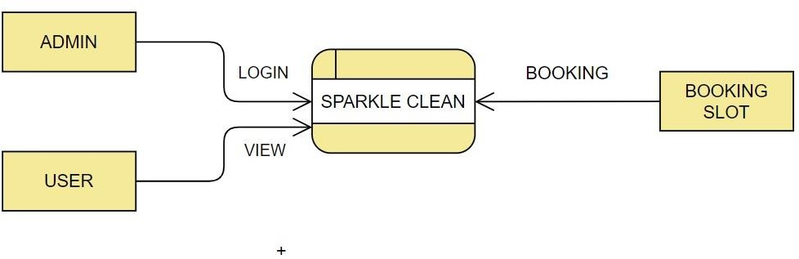

## Level 1 DFD:

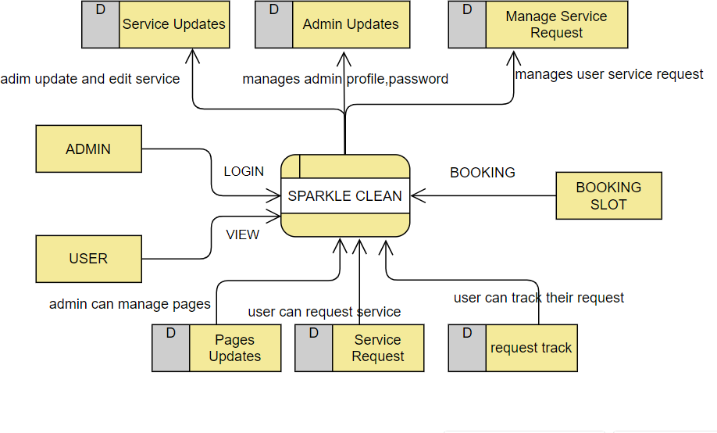

* 1. **Entity Relationship Diagram**

A graphical representation of the entities and the relationships between them. Entity relationship diagrams are a useful medium to achieve a common understanding of data among users and application developers.

In data modelling, an entity-relationship model (ERM) is a representation of structured data; entity-relationship modelling is the process of generating these models. The end-product of the modelling process is an entity-relationship diagram (ERD), a type of Conceptual Data Model or Semantic Data Model.

### Advantages of ERD

* **Visual Representation**:

The most significant advantage of using ERD is that it provides a visual representation of the layout. Being able to identify the flow of data and the operation of the entire system is made easier by having a well-designed database. The use of ERD in conjunction with data-flow diagrams results in a visual representation that is appropriate.

### Effective communication

The successful flow of information and communication is ensured by the clear depiction of the data, which is provided under appropriate titles and in appropriate tables. The link between diverse areas is simply comprehended by the audience members. Different symbols are used to represent different types of information. There are various symbols for representing different information like relationships are represented by diamond-shaped boxes, ovals and entities represent attributes are represented by rectangular boxes. These symbols allow the designer to have a proper [understanding of the working of the database](https://digitalgyan.org/how-to-understand-the-benefits-of-microsoft-access-forms-to-create-a-user-friendlier-database/) after completion.

### Easy to Understand:

Expert designers can easily create entity relationship diagrams. These are designed solely so that all individuals can understand them easily. Before actually [designing the database,](https://digitalgyan.org/5-most-popular-database-designing-tools-you-can-use/) the designers are required to get the design confirmed and approved by the representatives who are to use this data. The representatives have the right to give their suggestions for rectifying the issues related to the designer. Their contribution can play an [important role in enhancing the](https://digitalgyan.org/website-designer-primary-roles-and-importance-of-a-designer/) [overall design.](https://digitalgyan.org/website-designer-primary-roles-and-importance-of-a-designer/)

### High flexibility:

This is yet another feature of ERD models. Though the complete database is linked to information in different tables, the readers can quickly make out the relationship between various tables. There are several other mathematical formulae that can be used to determine the relationships.

Entity-relationship diagrams (ERDs) are vital components of corporate organisations because they are useful in organising large amounts of data in a simple and straightforward manner. It serves as a blueprint for the current database, allowing the designers to produce an exact design that is tailored to the goals and requirements of the firm and the project. The ERD paradigm increases the efficiency of data transfer. These innovative and straightforward diagrams serve as the most effective tool for corporate organisations, helping them to easily maintain their databases.

### Disadvantages of ER Model

* Limited constraints and specification.
* Loss of information content: Some information be lost or hidden in ER model.
* Limited relationship representation: ER model represents limited relationship as compared to another data models like relational model etc.
* No representation of data manipulation: It is difficult to show data manipulation in. model.
* Popular for high level design: ER model is very popular for designing high level design.
* No industry standard for notation.

### Features of ER Diagrams:

* Conceptual simplicity. If relationships between entities and attributes are known, an ERD can be quickly drawn.
* Explicit visual representation. The database structure can be easily comprehended after consulting the diagram.
* Communication effectiveness.
* Immense flexibility.
* The data requirements are easily understandable using an E - R model as it utilises clear diagrams. The E-R model can be easily converted into a relational database. The E-R diagram is extremely easy to understand as it has clearly defined entities and the relations between them.
* Only for relational data: Understand that the purpose is to show relationships. ER diagrams show only that relational structure. Not for unstructured data: Unless this cleanly delineated into different fields, rows or columns, ER diagrams are probably of limited use.

### Components of ER Diagram:

|  |  |  |
| --- | --- | --- |
| **Symbol** | **Name** |  |
|  | Attribute | An attribute describes the property of an entity. An attribute is represented as Oval in an ER diagram. |
|  | Derived Attribute | A derived attribute is one whose value is dynamic and derived from another attribute. It is represented by **dashed oval** in an ER Diagram. |
|  | Entity | An entity relationship diagram (ERD) shows the relationships of entity sets stored in a database. An entity in this context is an object, a component of data. An entity set is a collection of similar entities. These entities can have attributes that define its properties |
|  | Multivalued Attribute | An attribute that can hold multiple values is known as multivalued attribute. It is represented with **double ovals** in an ER Diagram. |
|  | Relationship | A relationship is represented by diamond shape in ER diagram, it shows the relationship among entities. |

**3..3.5 ER DIGRAM**

CLEANING SERVICE

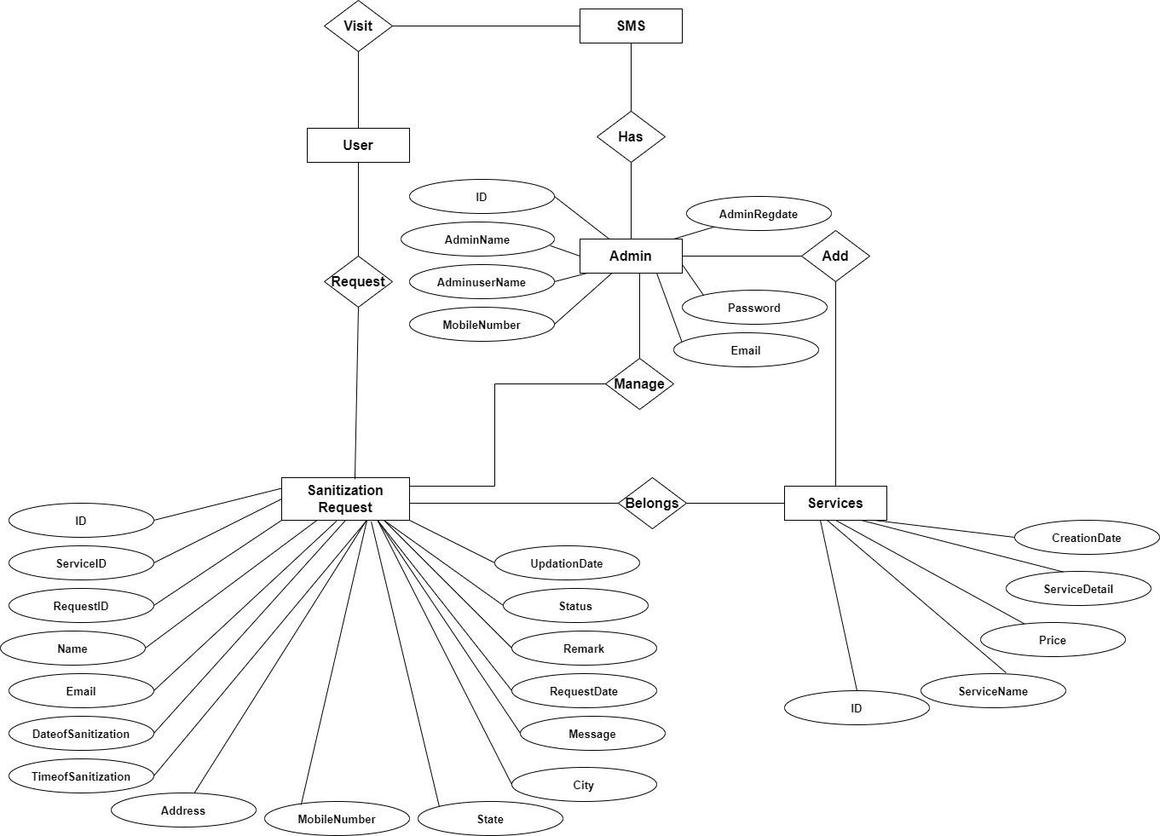

**D.O. SERVICE**

**T.O. SERVICE**

## Database Design

The data in the system must be stored and retrieved from database. Designing the database is part of system design. Data elements and data structures to be stored have been identified at analysis stage. They are structured and put together to design the data storage and retrieval system. A database is a collection of interrelated data stored with minimum redundancy to serve many users quickly and efficiently. The general objective is to make database access easy, quick, inexpensive, and flexible for the user. Relationships are established between the data items and unnecessary data items are removed. Normalization is done to get an internal consistency of data and to have minimum redundancy and maximum stability. This ensures minimizing data storage required, minimizing chances of data inconsistencies, and optimizing for updates. The MS Access database has been chosen for developing the relevant database

* + 1. **Admin Table** (table name is tbladmin) This store admin personal and login details.

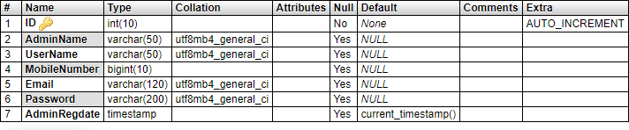

* + 1. **Service Table** (table name is tbladmin)

This table store the detail of sanitization Services.

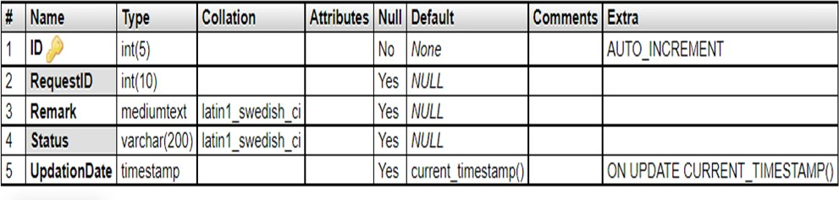

* + 1. **Request Table:** (Table name is tblrequest)

This table stores the detail of user who wants to sanitize there home or offices .

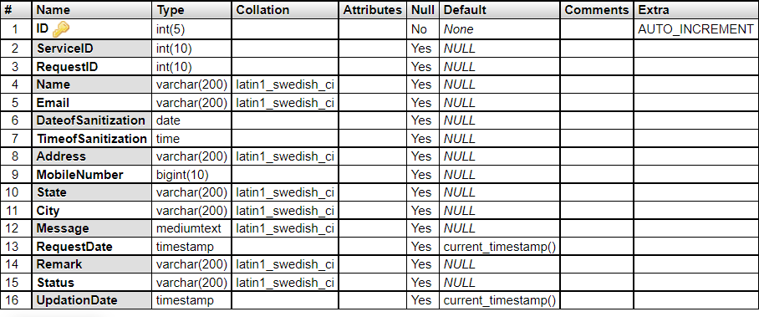

* + 1. **Tracking Table** (table name tbltracking)

This table store the detail of state of sanitization process.

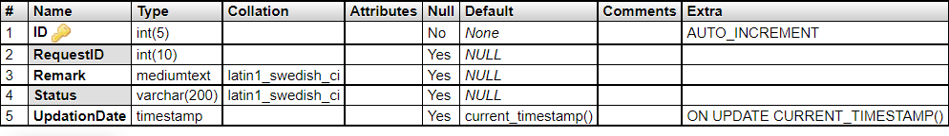

* + 1. 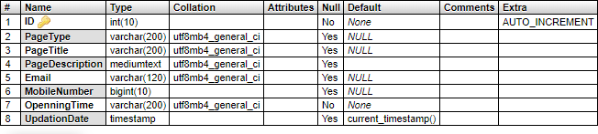**Page Table** (table name tblpage ) This table store About us Contact us details.

# CODING

## Home page

<!doctype html>

<html lang="en">

<head>

<title>Sparkle Clean || Home Page</title>

<link href="[https://fonts.googleapis.com/css2?family=Kumbh+Sans:wght@300;400;700&display=s](https://fonts.googleapis.com/css2?family=Kumbh%2BSans%3Awght%40300%3B400%3B700&display=s) wap" rel="stylesheet">

<!-- Template CSS -->

<link rel="stylesheet" href="assets/css/style-starter.css">

</head>

<body>

<?php include_once('includes/topbar.php');?>

<!-- main-slider -->

<section class="w3l-main-slider" id="home">

<div class="companies20-content">

<div class="owl-one owl-carousel owl-theme">

<div class="item">

<li>

<div class="slider-info banner-view bg bg">

<div class="banner-info">

<div class="container">

<div class="banner-info-bg">

<h5>Full Home Deep <span>Cleaninig services.</span> </h5>

<p class="mt-md-4 mt-3">Sparkle Clean is one of the Professional House Cleaning Services in India. We can clean your house and make it ready in no time. </p>

<a class="btn btn-style btn-primary mt-sm-5 mt-4 mr-2" href="about.php"> Learn More</a>

</div>

</div>

</div>

</div>

</li>

</div>

<div class="item">

<li>

<div class="slider-info banner-view banner-top1 bg bg2">

<div class="banner-info">

<div class="container">

<div class="banner-info-bg">

<h5>Sanitizing <span> services</span> </h5>

<p class="mt-md-4 mt-3"> Free from bacteria and viruses, free from mold and mildew.Imagine your home so clean, it’s clinically clean. </p>

<a class="btn btn-style btn-primary mt-sm-5 mt-4 mr-2" href="about.php"> Learn More</a>

</div>

</div>

</div>

</div>

</li>

</div>

<div class="item">

<li>

<div class="slider-info banner-view banner-top2 bg bg3">

<div class="banner-info">

<div class="container">

<div class="banner-info-bg">

<h5>Kitchen and Bathroom<span>Cleaning Services.</span> </h5>

<p class="mt-md-4 mt-3"> We offer customized and Best Kitchen and Bathroom Cleaning services to deliver the sparkling outcome to the clients.Our team will help you maintain a hygienic and clean environment in your kitchen and bathrrom. </p>

<a class="btn btn-style btn-primary mt-sm-5 mt-4 mr-2" href="about.php"> Learn

More</a>

</div>

</div>

</div>

</div>

</li>

</div>

<div class="item">

<li>

<div class="slider-info banner-view banner-top3 bg bg2">

<div class="banner-info">

<div class="container">

<div class="banner-info-bg">

<h5>Sofa and Carpet <span> Cleaning Services</span> </h5>

<p class="mt-md-4 mt-3"> This service is suitable for carpets and sofa cleaning in high traffic areas, to remove most stains on upholstery or for an annual clean up to reduce the allergies caused by dirty carpets or upholstery </p>

<a class="btn btn-style btn-primary mt-sm-5 mt-4 mr-2" href="about.php"> Learn

More</a>

</div>

</div>

</div>

</div>

</li>

</div>

</div>

</div>

</section>

<!-- /main-slider -->

<!-- our products -->

<section class="w3l-products py-5" id="services">

<div class="container py-lg-5 py-md-4 py-2">

<div class="row">

<div class="col-lg-12 mx-auto">

<!--Horizontal Tab-->

<div id="parentHorizontalTab">

<ul class="resp-tabs-list hor_1">

<li>Sanitization</li>

<li>Home cleaning</li>

<div class="clear"></div>

</ul>

<div class="resp-tabs-container hor_1 mt-md-0 mt-4">

<div class="products-content">

<div class="row">

<div class="col-lg-6">

<h3>Sanitization</h3>

<p>Our professional home sanitization services guarantee a clean and germ-free living environment. Our trained experts utilize advanced equipment and eco-friendly products to ensure maximum hygiene and peace of mind. We offer comprehensive disinfection, targeting surfaces, high-touch areas, and hard-to-reach spots. Our methods include chemical disinfection, electrostatic spraying, UV-C light treatment, and steam cleaning. We pay meticulous attention to detail, leaving no corner untouched. Our goal is to eliminate harmful germs, viruses, and bacteria, providing you and your loved ones with a safe and healthy home</p>

<a href="services.php" class="btn btn-outline-primary btn-style mt-3">Get Service Now

<span class="fa fa-chevron-right"></span>

</a>

</div>

<div class="col-lg-6 mt-lg-0 mt-5">

<img src="assets/images/residentsan.jpg" class="img-fluid radius-image-full" alt="project image">

</div>

</div>

</div>

<div class="products-content">

<div class="row">

<div class="col-lg-6">

<h3>Home cleaning</h3>

<p>We use the latest gadgets and equipment like single disk machines, high-end vacuum cleaners, small wipers, microfiber dusters, and many more. Sparkle Clean is one of the pioneering companies for best deep cleaning services providers, offering 100% client satisfaction. The professionals will clean the home thoroughly, lasting 2 to 3 months. Our team consists of certified and well-trained cleaners</p>

<div class="grids-ser my-md-5 my-4 text-center">

<div class="area-box">

<h4><a href="#feature" class="title-head">1 BHK </a></h4>

</div>

<div class="area-box">

<h4><a href="#feature" class="title-head">2 BHK</a></h4>

</div>

<div class="area-box">

<h4><a href="#feature" class="title-head">3 BHK </a></h4>

</div>

</div>

<a href="services.php" class="btn btn-outline-primary btn-style mt-3">Get Service Now

<span class="fa fa-chevron-right"></span>

</a>

</div>

<div class="col-lg-6 mt-lg-0 mt-5">

<img src="assets/images/home3.jpg" class="img-fluid radius-image-full"

alt="project image">

</div>

</div>

</div>

</div>

</div>

</div>

</div>

</div>

</section>

<!-- //our products -->

<!-- home block3 -->

<section class="wthree-row py-5 about-main" id="">

<div class="container py-lg-5 py-md-4 py-2">

<div class="row">

<div class="col-lg-6 mb-lg-0 mb-sm-5 mb-4">

<h3 class="title-small mb-2">SAVE TIME FOR YOUR FAMILY.</h3>

<h3 class="title-big">WE CLEAN FOR YOU! </h3>

<p class="pt-4"> We have a group of certified Home cleaners and our main aim is to ensure your convenience. We assure you to deliver world-class home cleaning services while promising you to offer safety of your home and assets.Apart from this, our professionals also help you in keeping your family healthy by living stress-free in a fully sanitized and calm place. We endeavor to help you live a fully comfortable and happy life.

</p>

<a href="about.php" class="btn btn-style btn-primary mt-lg-5 mt-4">Know More</a>

</div>

<div class="col-lg-6 text-center">

<div class="agileits-banner-info4">

<img src="assets/images/home5.png" alt="image" class="img-fluid radius-image" />

</div>

</div>

</div>

</div>

</section>

<!-- //home block3 -->

<!-- footer -->

<?php include_once('includes/footer.php');?>

<!-- javascripts file here -->

<script src="assets/js/jquery-3.3.1.min.js"></script>

<script src="assets/js/jquery-1.9.1.min.js"></script>

<script src="assets/js/theme-change.js"></script> <!-- //light and dark mode switch js -->

<!-- responsive tabs -->

<script src="assets/js/easyResponsiveTabs.js"></script>

<!--Plug-in Initialisation-->

<script type="text/javascript">

$(document).ready(function () {

//Horizontal Tab

$('#parentHorizontalTab').easyResponsiveTabs({ type: 'default', //Types: default, vertical, accordion width: 'auto', //auto or any width like 600px

fit: true, // 100% fit in a container

tabidentify: 'hor_1', // The tab groups identifier

activate: function (event) { // Callback function if tab is switched var $tab = $(this);

var $info = $('#nested-tabInfo'); var $name = $('span', $info);

$name.text($tab.text());

$info.show();

}

});

});

</script>

<script type="text/javascript">

$(document).ready(function () {

//Horizontal Tab

$('#parentHorizontalTab1').easyResponsiveTabs({ type: 'default', //Types: default, vertical, accordion width: 'auto', //auto or any width like 600px

fit: true, // 100% fit in a container

tabidentify: 'hor_2', // The tab groups identifier

activate: function (event) { // Callback function if tab is switched var $tab = $(this);

var $info = $('#nested-tabInfo'); var $name = $('span', $info);

$name.text($tab.text());

$info.show();

}

});

});

</script>

<!-- owl carousel -->

<script src="assets/js/owl.carousel.js"></script>

<!-- script for banner slider-->

<script>

$(document).ready(function () {

$('.owl-one').owlCarousel({ loop: true,

margin: 0, nav: false,

responsiveClass: true, autoplay: true, autoplayTimeout: 5000,

autoplaySpeed: 1000, autoplayHoverPause: false, responsive: {

0: {

items: 1

},

480: {

items: 1

},

667: {

items: 1

},

1000: {

items: 1

}

}

})

})

</script>

<!-- //script -->

<!-- owl carousel -->

<!-- script for tesimonials carousel slider -->

<script>

$(document).ready(function () {

$("#owl-demo1").owlCarousel({ loop: true,

nav: false, responsiveClass: true, responsive: {

0: {

items: 1, nav: false

},

736: {

items: 1, nav: false

}

}

})

})

</script>

<!-- //script for tesimonials carousel slider -->

<!-- disable body scroll which navbar is in active -->

<script>

$(function () {

$('.navbar-toggler').click(function () {

$('body').toggleClass('noscroll');

})

});

</script>

<!-- disable body scroll which navbar is in active -->

<!--/MENU-JS-->

<script>

$(window).on("scroll", function () { var scroll = $(window).scrollTop();

if (scroll >= 80) {

$("#site-header").addClass("nav-fixed");

} else {

$("#site-header").removeClass("nav-fixed");

}

});

//Main navigation Active Class Add Remove

$(".navbar-toggler").on("click", function () {

$("header").toggleClass("active");

});

$(document).on("ready", function () { if ($(window).width() > 991) {

$("header").removeClass("active");

}

$(window).on("resize", function () {

if ($(window).width() > 991) {

$("header").removeClass("active");

}

});

});

</script>

<!--//MENU-JS-->

<script src="assets/js/bootstrap.min.js"></script><!-- //bootstrap js -->

<script src="https://kit.fontawesome.com/9e5ba2e3f5.js" crossorigin="anonymous"></script>

</body>

</html>

## About us

<?php session_start(); error_reporting(0);

include('includes/config.php');

?>

<!doctype html>

<html lang="en">

<head>

<title>Sparkle Clean || Contact Us Page</title>

<link href="[https://fonts.googleapis.com/css2?family=Kumbh+Sans:wght@300;400;700&display=s](https://fonts.googleapis.com/css2?family=Kumbh%2BSans%3Awght%40300%3B400%3B700&display=s) wap" rel="stylesheet">

<!-- Template CSS -->

<link rel="stylesheet" href="assets/css/style-starter.css">

</head>

<body>

<?php include_once('includes/topbar.php');?>

<section class="w3l-about-breadcrumb">

<div class="breadcrumb-bg breadcrumb-bg-about py-5">

<div class="container py-lg-5 py-md-3">

<h2 class="title">Contact Us</h2>

</div>

</div>

</section>

<!-- contact block -->

<section class="wthree-row py-5 about-main" id="contact">

<div class="container py-lg-5 py-md-4 py-2">

<div class="row">

<div class="col-lg-6 mb-lg-0 mb-lg-5">

<h3 class="title-small mb-2">Get in touch with us</h3>

<h3 class="title-big">Let's discuss any Services enquiry </h3>

</div>

<div class="col-lg-6">

<p class="pt-4">We are dedicated to the safety of our guests and employees and have updated our safety

measures. We believe in Simple, Creative, Modern and Flexible Design Standards with a Retina and

Responsive Approach.</p>

</div>

</div>

<div class="d-grid contact my-md-5 my-4 pt-lg-3">

<div class="contact-info-left d-grid text-center">

<?php

$ret=mysqli_query($con,"select * from tblpage where PageType='contactus' ");

$cnt=1;

while ($row=mysqli_fetch_array($ret)) {

?>

<div class="contact-info">

<img src="assets/images/office.png" alt="" class="img-fluid">

<h4>Contact Address</h4>

<p><?php echo $row['PageDescription'];?>.</p>

</div>

<div class="contact-info">

<img src="assets/images/envelope.png" alt="" class="img-fluid">

<h4>Email address</h4>

<p><?php echo $row['Email'];?></p>

</div>

<div class="contact-info">

<img src="assets/images/support.png" alt="" class="img-fluid">

<h4>Contact phone</h4>

<p>+<?php echo $row['MobileNumber'];?></p>

</div>

<div class="contact-info">

<img src="assets/images/time.png" alt="" class="img-fluid">

<h4>Opening hours</h4>

<p>Mon-Fri: <?php echo $row['Timing'];?></p>

<p>Sat-Sun: Closed</p>

</div>

</div><?php } ?>

</div>

</div>

</section>

<!-- //contact block -->

<?php include_once('includes/footer.php');?>

<!-- javascripts file here -->

<script src="assets/js/jquery-3.3.1.min.js"></script>

<script src="assets/js/jquery-1.9.1.min.js"></script>

<script src="assets/js/theme-change.js"></script> <!-- //light and dark mode switch js -->

<!-- responsive tabs -->

<script src="assets/js/easyResponsiveTabs.js"></script>

<!--Plug-in Initialisation-->

<script type="text/javascript">

$(document).ready(function () {

//Horizontal Tab

$('#parentHorizontalTab').easyResponsiveTabs({ type: 'default', //Types: default, vertical, accordion width: 'auto', //auto or any width like 600px

fit: true, // 100% fit in a container

tabidentify: 'hor_1', // The tab groups identifier

activate: function (event) { // Callback function if tab is switched var $tab = $(this);

var $info = $('#nested-tabInfo'); var $name = $('span', $info);

$name.text($tab.text());

$info.show();

}

});

});

</script>

<script type="text/javascript">

$(document).ready(function () {

//Horizontal Tab

$('#parentHorizontalTab1').easyResponsiveTabs({ type: 'default', //Types: default, vertical, accordion

width: 'auto', //auto or any width like 600px fit: true, // 100% fit in a container

tabidentify: 'hor_2', // The tab groups identifier

activate: function (event) { // Callback function if tab is switched var $tab = $(this);

var $info = $('#nested-tabInfo'); var $name = $('span', $info);

$name.text($tab.text());

$info.show();

}

});

});

</script>

<!-- owl carousel -->

<script src="assets/js/owl.carousel.js"></script>

<!-- script for banner slider-->

<script>

$(document).ready(function () {

$('.owl-one').owlCarousel({ loop: true,

margin: 0, nav: false,

responsiveClass: true, autoplay: true, autoplayTimeout: 5000,

autoplaySpeed: 1000, autoplayHoverPause: false, responsive: {

0: {

items: 1

},

480: {

items: 1

},

667: {

items: 1

},

1000: {

items: 1

}

}

})

})

</script>

<!-- //script -->

<!-- owl carousel -->

<!-- script for tesimonials carousel slider -->

<script>

$(document).ready(function () {

$("#owl-demo1").owlCarousel({ loop: true,

nav: false, responsiveClass: true, responsive: {

0: {

items: 1, nav: false

},

736: {

items: 1, nav: false

}

}

})

})

</script>

<!-- //script for tesimonials carousel slider -->

<!-- disable body scroll which navbar is in active -->

<script>

$(function () {

$('.navbar-toggler').click(function () {

$('body').toggleClass('noscroll');

})

});

</script>

<!-- disable body scroll which navbar is in active -->

<!--/MENU-JS-->

<script>

$(window).on("scroll", function () { var scroll = $(window).scrollTop(); if (scroll >= 80) {

$("#site-header").addClass("nav-fixed");

} else {

$("#site-header").removeClass("nav-fixed");

}

});

//Main navigation Active Class Add Remove

$(".navbar-toggler").on("click", function () {

$("header").toggleClass("active");

});

$(document).on("ready", function () { if ($(window).width() > 991) {

$("header").removeClass("active");

}

$(window).on("resize", function () {

if ($(window).width() > 991) {

$("header").removeClass("active");

}

});

});

</script>

<!--//MENU-JS-->

<script src="assets/js/bootstrap.min.js"></script><!-- //bootstrap js -->

</body>

## Services

<?php session_start(); error_reporting(0);

include('includes/config.php');

?>

<!doctype html>

<html lang="en">

<head>

<title>Sparkle Clean || Contact Us Page</title>

<link href="[https://fonts.googleapis.com/css2?family=Kumbh+Sans:wght@300;400;700&display=s](https://fonts.googleapis.com/css2?family=Kumbh%2BSans%3Awght%40300%3B400%3B700&display=s) wap" rel="stylesheet">

<!-- Template CSS -->

<link rel="stylesheet" href="assets/css/style-starter.css">

</head>

<body>

<?php include_once('includes/topbar.php');?>

<section class="w3l-about-breadcrumb">

<div class="breadcrumb-bg breadcrumb-bg-about py-5">

<div class="container py-lg-5 py-md-3">

<h2 class="title">Contact Us</h2>

</div>

</div>

</section>

<!-- contact block -->

<section class="wthree-row py-5 about-main" id="contact">

<div class="container py-lg-5 py-md-4 py-2">

<div class="row">

<div class="col-lg-6 mb-lg-0 mb-lg-5">

<h3 class="title-small mb-2">Get in touch with us</h3>

<h3 class="title-big">Let's discuss any Services enquiry </h3>

</div>

<div class="col-lg-6">

<p class="pt-4">We are dedicated to the safety of our guests and employees and have updated our safety

measures. We believe in Simple, Creative, Modern and Flexible Design Standards with a Retina and

Responsive Approach.</p>

</div>

</div>

<div class="d-grid contact my-md-5 my-4 pt-lg-3">

<div class="contact-info-left d-grid text-center">

<?php

$ret=mysqli_query($con,"select * from tblpage where PageType='contactus' ");

$cnt=1;

while ($row=mysqli_fetch_array($ret)) {

?>

<div class="contact-info">

<img src="assets/images/office.png" alt="" class="img-fluid">

<h4>Contact Address</h4>

<p><?php echo $row['PageDescription'];?>.</p>

</div>

<div class="contact-info">

<img src="assets/images/envelope.png" alt="" class="img-fluid">

<h4>Email address</h4>

<p><?php echo $row['Email'];?></p>

</div>

<div class="contact-info">

<img src="assets/images/support.png" alt="" class="img-fluid">

<h4>Contact phone</h4>

<p>+<?php echo $row['MobileNumber'];?></p>

</div>

<div class="contact-info">

<img src="assets/images/time.png" alt="" class="img-fluid">

<h4>Opening hours</h4>

<p>Mon-Fri: <?php echo $row['Timing'];?></p>

<p>Sat-Sun: Closed</p>

</div>

</div><?php } ?>

</div>

</div>

</section>

<!-- //contact block -->

<?php include_once('includes/footer.php');?>

<!-- javascripts file here -->

<script src="assets/js/jquery-3.3.1.min.js"></script>

<script src="assets/js/jquery-1.9.1.min.js"></script>

<script src="assets/js/theme-change.js"></script> <!-- //light and dark mode switch js -->

<!-- responsive tabs -->

<script src="assets/js/easyResponsiveTabs.js"></script>

<!--Plug-in Initialisation-->

<script type="text/javascript">

$(document).ready(function () {

//Horizontal Tab

$('#parentHorizontalTab').easyResponsiveTabs({ type: 'default', //Types: default, vertical, accordion width: 'auto', //auto or any width like 600px

fit: true, // 100% fit in a container

tabidentify: 'hor_1', // The tab groups identifier

activate: function (event) { // Callback function if tab is switched var $tab = $(this);

var $info = $('#nested-tabInfo'); var $name = $('span', $info);

$name.text($tab.text());

$info.show();

}

});

});

</script>

<script type="text/javascript">

$(document).ready(function () {

//Horizontal Tab

$('#parentHorizontalTab1').easyResponsiveTabs({ type: 'default', //Types: default, vertical, accordion width: 'auto', //auto or any width like 600px

fit: true, // 100% fit in a container

tabidentify: 'hor_2', // The tab groups identifier

activate: function (event) { // Callback function if tab is switched var $tab = $(this);

var $info = $('#nested-tabInfo'); var $name = $('span', $info);

$name.text($tab.text());

$info.show();

}

});

});

</script>

<!-- owl carousel -->

<script src="assets/js/owl.carousel.js"></script>

<!-- script for banner slider-->

<script>

$(document).ready(function () {

$('.owl-one').owlCarousel({ loop: true,

margin: 0, nav: false,

responsiveClass: true, autoplay: true, autoplayTimeout: 5000,

autoplaySpeed: 1000, autoplayHoverPause: false, responsive: {

0: {

items: 1

},

480: {

items: 1

},

667: {

items: 1

},

1000: {

items: 1

}

}

})

})

</script>

<!-- //script -->

<!-- owl carousel -->

<!-- script for tesimonials carousel slider -->

<script>

$(document).ready(function () {

$("#owl-demo1").owlCarousel({ loop: true,

nav: false, responsiveClass: true, responsive: {

0: {

items: 1, nav: false

},

736: {

items: 1, nav: false

}

}

})

})

</script>

<!-- //script for tesimonials carousel slider -->

<!-- disable body scroll which navbar is in active -->

<script>

$(function () {

$('.navbar-toggler').click(function () {

$('body').toggleClass('noscroll');

})

});

</script>

<!-- disable body scroll which navbar is in active -->

<!--/MENU-JS-->

<script>

$(window).on("scroll", function () { var scroll = $(window).scrollTop(); if (scroll >= 80) {

$("#site-header").addClass("nav-fixed");

} else {

$("#site-header").removeClass("nav-fixed");

}

});

//Main navigation Active Class Add Remove

$(".navbar-toggler").on("click", function () {

$("header").toggleClass("active");

});

$(document).on("ready", function () { if ($(window).width() > 991) {

$("header").removeClass("active");

}

$(window).on("resize", function () {

if ($(window).width() > 991) {

$("header").removeClass("active");

}

});

});

</script>

<!--//MENU-JS-->

<script src="assets/js/bootstrap.min.js"></script><!-- //bootstrap js -->

</body>

</html>

## Contact us

<?php session_start(); error_reporting(0);

include('includes/config.php');

?>

<!doctype html>

<html lang="en">

<head>

<title>Sparkle Clean || Contact Us Page</title>

<link href="[https://fonts.googleapis.com/css2?family=Kumbh+Sans:wght@300;400;700&display=s](https://fonts.googleapis.com/css2?family=Kumbh%2BSans%3Awght%40300%3B400%3B700&display=s) wap" rel="stylesheet">

<!-- Template CSS -->

<link rel="stylesheet" href="assets/css/style-starter.css">

</head>

<body>

<?php include_once('includes/topbar.php');?>

<section class="w3l-about-breadcrumb">

<div class="breadcrumb-bg breadcrumb-bg-about py-5">

<div class="container py-lg-5 py-md-3">

<h2 class="title">Contact Us</h2>

</div>

</div>

</section>

<!-- contact block -->

<section class="wthree-row py-5 about-main" id="contact">

<div class="container py-lg-5 py-md-4 py-2">

<div class="row">

<div class="col-lg-6 mb-lg-0 mb-lg-5">

<h3 class="title-small mb-2">Get in touch with us</h3>

<h3 class="title-big">Let's discuss any Services enquiry </h3>

</div>

<div class="col-lg-6">

<p class="pt-4">We are dedicated to the safety of our guests and employees and have updated our safety

measures. We believe in Simple, Creative, Modern and Flexible Design Standards with a Retina and

Responsive Approach.</p>

</div>

</div>

<div class="d-grid contact my-md-5 my-4 pt-lg-3">

<div class="contact-info-left d-grid text-center">

<?php

$ret=mysqli_query($con,"select * from tblpage where PageType='contactus' ");

$cnt=1;

while ($row=mysqli_fetch_array($ret)) {

?>

<div class="contact-info">

<img src="assets/images/office.png" alt="" class="img-fluid">

<h4>Contact Address</h4>

<p><?php echo $row['PageDescription'];?>.</p>

</div>

<div class="contact-info">

<img src="assets/images/envelope.png" alt="" class="img-fluid">

<h4>Email address</h4>

<p><?php echo $row['Email'];?></p>

</div>

<div class="contact-info">

<img src="assets/images/support.png" alt="" class="img-fluid">

<h4>Contact phone</h4>

<p>+<?php echo $row['MobileNumber'];?></p>

</div>

<div class="contact-info">

<img src="assets/images/time.png" alt="" class="img-fluid">

<h4>Opening hours</h4>

<p>Mon-Fri: <?php echo $row['Timing'];?></p>

<p>Sat-Sun: Closed</p>

</div>

</div><?php } ?>

</div>

</div>

</section>

<!-- //contact block -->

<?php include_once('includes/footer.php');?>

<!-- javascripts file here -->

<script src="assets/js/jquery-3.3.1.min.js"></script>

<script src="assets/js/jquery-1.9.1.min.js"></script>

<script src="assets/js/theme-change.js"></script> <!-- //light and dark mode switch js -->

<!-- responsive tabs -->

<script src="assets/js/easyResponsiveTabs.js"></script>

<!--Plug-in Initialisation-->

<script type="text/javascript">

$(document).ready(function () {

//Horizontal Tab

$('#parentHorizontalTab').easyResponsiveTabs({ type: 'default', //Types: default, vertical, accordion width: 'auto', //auto or any width like 600px

fit: true, // 100% fit in a container

tabidentify: 'hor_1', // The tab groups identifier

activate: function (event) { // Callback function if tab is switched

var $tab = $(this);

var $info = $('#nested-tabInfo'); var $name = $('span', $info);

$name.text($tab.text());

$info.show();

}

});

});

</script>

<script type="text/javascript">

$(document).ready(function () {

//Horizontal Tab

$('#parentHorizontalTab1').easyResponsiveTabs({ type: 'default', //Types: default, vertical, accordion width: 'auto', //auto or any width like 600px

fit: true, // 100% fit in a container

tabidentify: 'hor_2', // The tab groups identifier

activate: function (event) { // Callback function if tab is switched var $tab = $(this);

var $info = $('#nested-tabInfo'); var $name = $('span', $info);

$name.text($tab.text());

$info.show();

}

});

});

</script>

<!-- owl carousel -->

<script src="assets/js/owl.carousel.js"></script>

<!-- script for banner slider-->

<script>

$(document).ready(function () {

$('.owl-one').owlCarousel({ loop: true,

margin: 0, nav: false,

responsiveClass: true, autoplay: true, autoplayTimeout: 5000,

autoplaySpeed: 1000, autoplayHoverPause: false, responsive: {

0: {

items: 1

},

480: {

items: 1

},

667: {

items: 1

},

1000: {

items: 1

}

}

})

})

</script>

<!-- //script -->

<!-- owl carousel -->

<!-- script for tesimonials carousel slider -->

<script>

$(document).ready(function () {

$("#owl-demo1").owlCarousel({ loop: true,

nav: false, responsiveClass: true, responsive: {

0: {

items: 1, nav: false

},

736: {

items: 1, nav: false

}

}

})

})

</script>

<!-- //script for tesimonials carousel slider -->

<!-- disable body scroll which navbar is in active -->

<script>

$(function () {

$('.navbar-toggler').click(function () {

$('body').toggleClass('noscroll');

})

});

</script>

<!-- disable body scroll which navbar is in active -->

<!--/MENU-JS-->

<script>

$(window).on("scroll", function () { var scroll = $(window).scrollTop(); if (scroll >= 80) {

$("#site-header").addClass("nav-fixed");

} else {

$("#site-header").removeClass("nav-fixed");

}

});

//Main navigation Active Class Add Remove

$(".navbar-toggler").on("click", function () {

$("header").toggleClass("active");

});

$(document).on("ready", function () { if ($(window).width() > 991) {

$("header").removeClass("active");

}

$(window).on("resize", function () {

if ($(window).width() > 991) {

$("header").removeClass("active");

}

});

});

</script>

<!--//MENU-JS-->

<script src="assets/js/bootstrap.min.js"></script><!-- //bootstrap js -->

</body>

</html>

## Service request

<?php session_start(); error_reporting(0);

include('includes/config.php'); if(isset($_POST['submit']))

{

$errors = array();

$sid= $_GET['sid'];

$requestid=mt_rand(100000000, 999999999);

$name=$_POST['name'];

$mobnum=$_POST['mobnum'];

$email=$_POST['email'];

$dos=$_POST['dos'];

$tom=$_POST['tom'];

$address=$_POST['address'];

$state=$_POST['state'];

$city=$_POST['city'];

$message=$_POST['message'];

// Validate name if(empty($name)){

$errors[] = "Name is required";

}

// Validate mobile number if(empty($mobnum)){

$errors[] = "Mobile number is required";

} elseif(!preg_match("/^[0-9]{10}$/", $mobnum)){

$errors[] = "Invalid mobile number";

}

// Validate email if(empty($email)){

$errors[] = "Email is required";

} elseif(!filter_var($email, FILTER_VALIDATE_EMAIL)){

$errors[] = "Invalid email address";

}

// Validate date of service if(empty($dos)){

$errors[] = "Date of sanitization is required";

}

// Validate time if(empty($tom)){

$errors[] = "Time of sanitization is required";

}

// Validate address if(empty($address)){

$errors[] = "Address is required";

}

// Validate state if(empty($state)){

$errors[] = "State is required";

}

// Validate city if(empty($city)){

$errors[] = "City is required";

}

// If there are no errors, insert the data into the database if(empty($errors)){

$query=mysqli_query($con,"insert into

tblrequest(ServiceID,RequestID,Name,Email,DateofSanitization,TimeofSanitization,Address, MobileNumber,State,City,Message) values('$sid','$requestid','$name','$email','$dos','$tom','$address','$mobnum','$state','$city','$mes sage') ");

if($query)

{

echo '<script>alert("Your request has been sent successfully. Your Request Number is '.$requestid.'")</script>';

echo "<script>window.location.href ='services.php'</script>";

} else {

echo "<script>alert('Something went wrong.');</script>";

}

} else {

$errorString = implode(", ", $errors);

echo '<script>alert("Validation Error: '.$errorString.'")</script>';

}

}

?>

<!doctype html>

<html lang="en">

<head>

<title>parkle Clean|| Request Form</title>

<link href="[https://fonts.googleapis.com/css2?family=Kumbh+Sans:wght@300;400;700&display=s](https://fonts.googleapis.com/css2?family=Kumbh%2BSans%3Awght%40300%3B400%3B700&display=s) wap" rel="stylesheet">

<!-- Template CSS -->

<link rel="stylesheet" href="assets/css/style-starter.css">

</head>

<body>

<?php include_once('includes/topbar.php');?>

<section class="w3l-about-breadcrumb">

<div class="breadcrumb-bg breadcrumb-bg-about py-5">

<div class="container py-lg-5 py-md-3">

<h2 class="title">Request Form</h2>

</div>

</div>

</section>

<!-- contact block -->

<section class="wthree-row py-5 about-main" id="contact">

<div class="container py-lg-5 py-md-4 py-2">

<div class="map-content-9 pt-lg-5">

<h5 class="mb-sm-4 mb-3">Book Your Service!!</h5>

<form method="post">

<div class="twice-two">

<input type="text" class="form-control" name="name" id="name" placeholder="Name" required="true">

<input type="email" class="form-control" name="email" id="email" placeholder="Email" required="true">

</div>

<div class="twice-two">

<input type="date" class="form-control" name="dos" id="dos" placeholder="Name" required="true">

<input type="time" class="form-control" name="tom" id="tom" placeholder="Email" required="true">

</div>

<div class="twice-two">

<input type="text" class="form-control" name="mobnum" id="mobnum" placeholder="Mobile Number" required="true">

<input type="text" class="form-control" name="address" id="address" placeholder="Address" required="true">

</div>

<div class="twice-two">

<input type="text" class="form-control" name="state" id="state" placeholder="State" required="true">

<input type="text" class="form-control" name="city" id="city" placeholder="City" required="true">

</div>

<textarea class="form-control" id="message" name="message" placeholder="Message(if any)"></textarea>

<div class="text-right">

<button type="submit" class="btn btn-primary btn-style mt-4" name="submit">Request</button>

</div>

</form>

</div>

</div>

</section>

<!-- //contact block -->

<?php include_once('includes/footer.php');?>

<!-- javascripts file here -->

<script src="assets/js/jquery-3.3.1.min.js"></script>

<script src="assets/js/jquery-1.9.1.min.js"></script>

<script src="assets/js/theme-change.js"></script> <!-- //light and dark mode switch js -->

<!-- responsive tabs -->

<script src="assets/js/easyResponsiveTabs.js"></script>

<!--Plug-in Initialisation-->

<script type="text/javascript">

$(document).ready(function () {

//Horizontal Tab

$('#parentHorizontalTab').easyResponsiveTabs({ type: 'default', //Types: default, vertical, accordion width: 'auto', //auto or any width like 600px

fit: true, // 100% fit in a container

tabidentify: 'hor_1', // The tab groups identifier

activate: function (event) { // Callback function if tab is switched var $tab = $(this);

var $info = $('#nested-tabInfo'); var $name = $('span', $info);

$name.text($tab.text());

$info.show();

}

});

});

</script>

<script type="text/javascript">

$(document).ready(function () {

//Horizontal Tab

$('#parentHorizontalTab1').easyResponsiveTabs({ type: 'default', //Types: default, vertical, accordion width: 'auto', //auto or any width like 600px

fit: true, // 100% fit in a container

tabidentify: 'hor_2', // The tab groups identifier

activate: function (event) { // Callback function if tab is switched var $tab = $(this);

var $info = $('#nested-tabInfo'); var $name = $('span', $info);

$name.text($tab.text());

$info.show();

}

});

});

</script>

<!-- owl carousel -->

<script src="assets/js/owl.carousel.js"></script>

<!-- script for banner slider-->

<script>

$(document).ready(function () {

$('.owl-one').owlCarousel({ loop: true,

margin: 0, nav: false,

responsiveClass: true, autoplay: true, autoplayTimeout: 5000,

autoplaySpeed: 1000, autoplayHoverPause: false, responsive: {

0: {

items: 1

},

480: {

items: 1

},

667: {

items: 1

},

1000: {

items: 1

}

}

})

})

</script>

<!-- //script -->

<!-- owl carousel -->

<!-- script for tesimonials carousel slider -->

<script>

$(document).ready(function () {

$("#owl-demo1").owlCarousel({ loop: true,

nav: false, responsiveClass: true, responsive: {

0: {

items: 1, nav: false

},

736: {

items: 1, nav: false

}

}

})

})

</script>

<!-- //script for tesimonials carousel slider -->

<!-- disable body scroll which navbar is in active -->

<script>

$(function () {

$('.navbar-toggler').click(function () {

$('body').toggleClass('noscroll');

})

});

</script>

<!-- disable body scroll which navbar is in active -->

<!--/MENU-JS-->

<script>

$(window).on("scroll", function () { var scroll = $(window).scrollTop(); if (scroll >= 80) {

$("#site-header").addClass("nav-fixed");

} else {

$("#site-header").removeClass("nav-fixed");

}

});

//Main navigation Active Class Add Remove

$(".navbar-toggler").on("click", function () {

$("header").toggleClass("active");

});

$(document).on("ready", function () { if ($(window).width() > 991) {

$("header").removeClass("active");

}

$(window).on("resize", function () {

if ($(window).width() > 991) {

$("header").removeClass("active");

}

});

});

</script>

<!--//MENU-JS-->

<script src="assets/js/bootstrap.min.js"></script><!-- //bootstrap js -->

</body>

</html>

## Track request

<?php session_start(); error_reporting(0);

include('includes/config.php');

?>

<!doctype html>

<html lang="en">

<head>

<title>Sparkle Clean || Contact Us Page</title>

<link href="[https://fonts.googleapis.com/css2?family=Kumbh+Sans:wght@300;400;700&display=s](https://fonts.googleapis.com/css2?family=Kumbh%2BSans%3Awght%40300%3B400%3B700&display=s) wap" rel="stylesheet">

<!-- Template CSS -->

<link rel="stylesheet" href="assets/css/style-starter.css">

</head>

<body>

<?php include_once('includes/topbar.php');?>

<section class="w3l-about-breadcrumb">

<div class="breadcrumb-bg breadcrumb-bg-about py-5">

<div class="container py-lg-5 py-md-3">

<h2 class="title">Contact Us</h2>

</div>

</div>

</section>

<!-- contact block -->

<section class="wthree-row py-5 about-main" id="contact">

<div class="container py-lg-5 py-md-4 py-2">

<div class="row">

<div class="col-lg-6 mb-lg-0 mb-lg-5">

<h3 class="title-small mb-2">Get in touch with us</h3>

<h3 class="title-big">Let's discuss any Services enquiry </h3>

</div>

<div class="col-lg-6">

<p class="pt-4">We are dedicated to the safety of our guests and employees and have updated our safety

measures. We believe in Simple, Creative, Modern and Flexible Design Standards with a Retina and

Responsive Approach.</p>

</div>

</div>

<div class="d-grid contact my-md-5 my-4 pt-lg-3">

<div class="contact-info-left d-grid text-center">

<?php

$ret=mysqli_query($con,"select * from tblpage where PageType='contactus' ");

$cnt=1;

while ($row=mysqli_fetch_array($ret)) {

?>

<div class="contact-info">

<img src="assets/images/office.png" alt="" class="img-fluid">

<h4>Contact Address</h4>

<p><?php echo $row['PageDescription'];?>.</p>

</div>

<div class="contact-info">

<img src="assets/images/envelope.png" alt="" class="img-fluid">

<h4>Email address</h4>

<p><?php echo $row['Email'];?></p>

</div>

<div class="contact-info">

<img src="assets/images/support.png" alt="" class="img-fluid">

<h4>Contact phone</h4>

<p>+<?php echo $row['MobileNumber'];?></p>

</div>

<div class="contact-info">

<img src="assets/images/time.png" alt="" class="img-fluid">

<h4>Opening hours</h4>

<p>Mon-Fri: <?php echo $row['Timing'];?></p>

<p>Sat-Sun: Closed</p>

</div>

</div><?php } ?>

</div>

</div>

</section>

<!-- //contact block -->

<?php include_once('includes/footer.php');?>

<!-- javascripts file here -->

<script src="assets/js/jquery-3.3.1.min.js"></script>

<script src="assets/js/jquery-1.9.1.min.js"></script>

<script src="assets/js/theme-change.js"></script> <!-- //light and dark mode switch j->

<!-- responsive tabs -->

<script src="assets/js/easyResponsiveTabs.js"></script>

<!--Plug-in Initialisation-->

<script type="text/javascript">

$(document).ready(function () {

//Horizontal Tab

$('#parentHorizontalTab').easyResponsiveTabs({ type: 'default', //Types: default, vertical, accordion width: 'auto', //auto or any width like 600px

fit: true, // 100% fit in a container

tabidentify: 'hor_1', // The tab groups identifier

activate: function (event) { // Callback function if tab is switched var $tab = $(this);

var $info = $('#nested-tabInfo'); var $name = $('span', $info);

$name.text($tab.text());

$info.show();

}

});

});

</script>

<script type="text/javascript">

$(document).ready(function () {

//Horizontal Tab

$('#parentHorizontalTab1').easyResponsiveTabs({ type: 'default', //Types: default, vertical, accordion width: 'auto', //auto or any width like 600px

fit: true, // 100% fit in a container

tabidentify: 'hor_2', // The tab groups identifier

activate: function (event) { // Callback function if tab is switched var $tab = $(this);

var $info = $('#nested-tabInfo'); var $name = $('span', $info);

$name.text($tab.text());

$info.show();

}

});

});

</script>

<!-- owl carousel -->

<script src="assets/js/owl.carousel.js"></script>

<!-- script for banner slider-->

<script>

$(document).ready(function () {

$('.owl-one').owlCarousel({ loop: true,

margin: 0, nav: false,

responsiveClass: true, autoplay: true, autoplayTimeout: 5000,

autoplaySpeed: 1000, autoplayHoverPause: false, responsive: {

0: {

items: 1

},

480: {

items: 1

},

667: {

items: 1

},

1000: {

items: 1

}

}

})

})

</script>

<!-- //script -->

<!-- owl carousel -->

<!-- script for tesimonials carousel slider -->

<script>

$(document).ready(function () {

$("#owl-demo1").owlCarousel({ loop: true,

nav: false, responsiveClass: true, responsive: {

0: {

items: 1, nav: false

},

736: {

items: 1, nav: false

}

}

})

})

</script>

<!-- //script for tesimonials carousel slider -->

<!-- disable body scroll which navbar is in active -->

<script>

$(function () {

$('.navbar-toggler').click(function () {

$('body').toggleClass('noscroll');

})

});

</script>

<!-- disable body scroll which navbar is in active -->

<!--/MENU-JS-->

<script>

$(window).on("scroll", function () {

var scroll = $(window).scrollTop(); if (scroll >= 80) {

$("#site-header").addClass("nav-fixed");

} else {

$("#site-header").removeClass("nav-fixed");

}

});

//Main navigation Active Class Add Remove

$(".navbar-toggler").on("click", function () {

$("header").toggleClass("active");

});

$(document).on("ready", function () { if ($(window).width() > 991) {

$("header").removeClass("active");

}

$(window).on("resize", function () {

if ($(window).width() > 991) {

$("header").removeClass("active");

}

});

});

</script>

<!--//MENU-JS-->

<script src="assets/js/bootstrap.min.js"></script><!-- //bootstrap js -->

</body>

</html>

## Footer

<?php error_reporting(0); include('includes/config.php');

?>

<footer class="py-5">

<div class="container py-lg-4 py-2">

<div class="row footer-top">

<div class="col-lg-6 footer-grid_section_1its footer-text">

<div class="footer-title">

<h3>About Us</h3>

</div>

<?php

$ret=mysqli_query($con,"select * from tblpage where PageType='aboutus' ");

$cnt=1;

while ($row=mysqli_fetch_array($ret)) {

?>

} ?>

<p class="mt-lg-4 mt-3 mb-4 pb-lg-2"><?php echo $row['PageDescription'];?>.</p><?php

<a href="contact.php" class=" link-style p-0">Contact

<span class="fa fa-chevron-right"></span>

</a>

</div>

<div class="col-lg-6 col-md-6 footer-grid_section_1its mt-lg-0 mt-5">

<div class="footer-title">

<h3>Contact Us</h3>

</div>

<div class="footer-text mt-4">

<?php

$ret=mysqli_query($con,"select * from tblpage where PageType='contactus' ");

$cnt=1;

while ($row=mysqli_fetch_array($ret)) {

?>

<p><strong>Address :</strong> <?php echo $row['PageDescription'];?>.</p>

<p class="my-2"><strong>Phone :</strong> <a href="tel:+<?php echo

$row['MobileNumber'];?>">+<?php echo $row['MobileNumber'];?></a></p>

<p><strong>Email :</strong> <a href="<?php echo $row['Email'];?>"><?php echo

$row['Email'];?></a></p>

<h4>Opening hours</h4>

<p>Mon-Fri: <?php echo $row['Timing'];?></p>

<p>Sat-Sun: Closed</p><?php } ?>

<!-- social icons -->

<ul class="top-right-info mt-4">

<li class="facebook-w3">

<a href="https:/[/www](http://www.facebook.com/sparklingcleanltd.co.uk/).[facebook.com/sparklingcleanltd.co.uk/"](http://www.facebook.com/sparklingcleanltd.co.uk/)>

<span class="fa fa-facebook-f"></span>

</a>

</li>

<li class="twitter-w3">

<a href="https://twitter.com/sparklingclean9">

<span class="fa fa-twitter"></span>

</a>

</li>

<li class="google-w3">

<a href="https:/[/www](http://www.google.com/maps/place/Christ%2BAcademy%2BInstitute%2Bfor%2BAdvanced%2BStudies).[google.com/maps/place/Christ+Academy+Institute+for+Advanced+Studies](http://www.google.com/maps/place/Christ%2BAcademy%2BInstitute%2Bfor%2BAdvanced%2BStudies)

+(CAIAS)/@12.8236531,77.6165562,17z/data=!3m1!4b1!4m6!3m5!1s0x3bae6ba5ac3ba5af:0 xad10753763de0897!8m2!3d12.8236531!4d77.6191311!16s%2Fg%2F11c0ph98n5?entry=ttu"

>

<span class="fa fa-google-plus"></span>

</a>

</li>

</ul>

<!-- //social icons -->

</div>

</div>

</div>

</div>

</footer>

<!-- //footer -->

<!-- copyright -->

<div class="cpy-right text-center py-4">

<p>Home Cleaning Service || Sparkle Clean </p>

</div>

<!-- //copyright -->

<!-- move top -->

<button onclick="topFunction()" id="movetop" title="Go to top">

<span class="fa fa-level-up" aria-hidden="true"></span>

</button>

<script>

// When the user scrolls down 20px from the top of the document, show the button window.onscroll = function () {

scrollFunction()

};

function scrollFunction() {

if (document.body.scrollTop > 20 || document.documentElement.scrollTop > 20) { document.getElementById("movetop").style.display = "block";

} else {

document.getElementById("movetop").style.display = "none";

}

}

// When the user clicks on the button, scroll to the top of the document function topFunction() {

document.body.scrollTop = 0;

document.documentElement.scrollTop = 0;

}

</script>

## Top bar

<?php error_reporting(0); include('includes/config.php');

?>

<footer class="py-5">

<div class="container py-lg-4 py-2">

<div class="row footer-top">

<div class="col-lg-6 footer-grid_section_1its footer-text">

<div class="footer-title">

<h3>About Us</h3>

</div>

<?php

$ret=mysqli_query($con,"select * from tblpage where PageType='aboutus' ");

$cnt=1;

while ($row=mysqli_fetch_array($ret)) {

?>

} ?>

<p class="mt-lg-4 mt-3 mb-4 pb-lg-2"><?php echo $row['PageDescription'];?>.</p><?php

<a href="contact.php" class=" link-style p-0">Contact

<span class="fa fa-chevron-right"></span>

</a>

</div>

<div class="col-lg-6 col-md-6 footer-grid_section_1its mt-lg-0 mt-5">

<div class="footer-title">

<h3>Contact Us</h3>

</div>

<div class="footer-text mt-4">

<?php

$ret=mysqli_query($con,"select * from tblpage where PageType='contactus' ");

$cnt=1;

while ($row=mysqli_fetch_array($ret)) {

?>

<p><strong>Address :</strong> <?php echo $row['PageDescription'];?>.</p>

<p class="my-2"><strong>Phone :</strong> <a href="tel:+<?php echo

$row['MobileNumber'];?>">+<?php echo $row['MobileNumber'];?></a></p>

<p><strong>Email :</strong> <a href="<?php echo $row['Email'];?>"><?php echo

$row['Email'];?></a></p>

<h4>Opening hours</h4>

<p>Mon-Fri: <?php echo $row['Timing'];?></p>

<p>Sat-Sun: Closed</p><?php } ?>

<!-- social icons -->

<ul class="top-right-info mt-4">

<li class="facebook-w3">

<a href="https:/[/www](http://www.facebook.com/sparklingcleanltd.co.uk/).[facebook.com/sparklingcleanltd.co.uk/"](http://www.facebook.com/sparklingcleanltd.co.uk/)>

<span class="fa fa-facebook-f"></span>

</a>

</li>

<li class="twitter-w3">

<a href="https://twitter.com/sparklingclean9">

<span class="fa fa-twitter"></span>

</a>

</li>

<li class="google-w3">

<a href="https:/[/www](http://www.google.com/maps/place/Christ%2BAcademy%2BInstitute%2Bfor%2BAdvanced%2BStudies).[google.com/maps/place/Christ+Academy+Institute+for+Advanced+Studies](http://www.google.com/maps/place/Christ%2BAcademy%2BInstitute%2Bfor%2BAdvanced%2BStudies)

+(CAIAS)/@12.8236531,77.6165562,17z/data=!3m1!4b1!4m6!3m5!1s0x3bae6ba5ac3ba5af:0 xad10753763de0897!8m2!3d12.8236531!4d77.6191311!16s%2Fg%2F11c0ph98n5?entry=ttu"

>

<span class="fa fa-google-plus"></span>

</a>

</li>

</ul>

<!-- //social icons -->

</div>

</div>

</div>

</div>

</footer>

<!-- //footer -->

<!-- copyright -->

<div class="cpy-right text-center py-4">

<p>Home Cleaning Service || Sparkle Clean </p>

</div>

<!-- //copyright -->

<!-- move top -->

<button onclick="topFunction()" id="movetop" title="Go to top">

<span class="fa fa-level-up" aria-hidden="true"></span>

</button>

<script>

// When the user scrolls down 20px from the top of the document, show the button window.onscroll = function () {

scrollFunction()

};

function scrollFunction() {

if (document.body.scrollTop > 20 || document.documentElement.scrollTop > 20) { document.getElementById("movetop").style.display = "block";

} else {

document.getElementById("movetop").style.display = "none";

}

}

// When the user clicks on the button, scroll to the top of the document function topFunction() {

document.body.scrollTop = 0;

document.documentElement.scrollTop = 0;

}

</script>

## About-us

<?php error_reporting(0); include('includes/config.php');

?>

<footer class="py-5">

<div class="container py-lg-4 py-2">

<div class="row footer-top">

<div class="col-lg-6 footer-grid_section_1its footer-text">

<div class="footer-title">

<h3>About Us</h3>

</div>

<?php

$ret=mysqli_query($con,"select * from tblpage where PageType='aboutus' ");

$cnt=1;

while ($row=mysqli_fetch_array($ret)) {

?>

} ?>

<p class="mt-lg-4 mt-3 mb-4 pb-lg-2"><?php echo $row['PageDescription'];?>.</p><?php

<a href="contact.php" class=" link-style p-0">Contact

<span class="fa fa-chevron-right"></span>

</a>

</div>

<div class="col-lg-6 col-md-6 footer-grid_section_1its mt-lg-0 mt-5">

<div class="footer-title">

<h3>Contact Us</h3>

</div>

<div class="footer-text mt-4">

<?php

$ret=mysqli_query($con,"select * from tblpage where PageType='contactus' ");

$cnt=1;

while ($row=mysqli_fetch_array($ret)) {

?>

<p><strong>Address :</strong> <?php echo $row['PageDescription'];?>.</p>

<p class="my-2"><strong>Phone :</strong> <a href="tel:+<?php echo

$row['MobileNumber'];?>">+<?php echo $row['MobileNumber'];?></a></p>

<p><strong>Email :</strong> <a href="<?php echo $row['Email'];?>"><?php echo

$row['Email'];?></a></p>

<h4>Opening hours</h4>

<p>Mon-Fri: <?php echo $row['Timing'];?></p>

<p>Sat-Sun: Closed</p><?php } ?>

<!-- social icons -->

<ul class="top-right-info mt-4">

<li class="facebook-w3">

<a href="https:/[/www](http://www.facebook.com/sparklingcleanltd.co.uk/).[facebook.com/sparklingcleanltd.co.uk/"](http://www.facebook.com/sparklingcleanltd.co.uk/)>

<span class="fa fa-facebook-f"></span>

</a>

</li>

<li class="twitter-w3">

<a href="https://twitter.com/sparklingclean9">

<span class="fa fa-twitter"></span>

</a>

</li>

<li class="google-w3">

<a href="https:/[/www](http://www.google.com/maps/place/Christ%2BAcademy%2BInstitute%2Bfor%2BAdvanced%2BStudies).[google.com/maps/place/Christ+Academy+Institute+for+Advanced+Studies](http://www.google.com/maps/place/Christ%2BAcademy%2BInstitute%2Bfor%2BAdvanced%2BStudies)

+(CAIAS)/@12.8236531,77.6165562,17z/data=!3m1!4b1!4m6!3m5!1s0x3bae6ba5ac3ba5af:0 xad10753763de0897!8m2!3d12.8236531!4d77.6191311!16s%2Fg%2F11c0ph98n5?entry=ttu"

>

<span class="fa fa-google-plus"></span>

</a>

</li>

</ul>

<!-- //social icons -->

</div>

</div>

</div>

</div>

</footer>

<!-- //footer -->

<!-- copyright -->

<div class="cpy-right text-center py-4">

<p>Home Cleaning Service || Sparkle Clean </p>

</div>

<!-- //copyright -->

<!-- move top -->

<button onclick="topFunction()" id="movetop" title="Go to top">

<span class="fa fa-level-up" aria-hidden="true"></span>

</button>

<script>

// When the user scrolls down 20px from the top of the document, show the button window.onscroll = function () {

scrollFunction()

};

function scrollFunction() {

if (document.body.scrollTop > 20 || document.documentElement.scrollTop > 20) { document.getElementById("movetop").style.display = "block";

} else {

document.getElementById("movetop").style.display = "none";

}

}

// When the user clicks on the button, scroll to the top of the document function topFunction() {

document.body.scrollTop = 0;

document.documentElement.scrollTop = 0;

}

</script>

## Dashboard

<?php session_start();

include_once('includes/config.php'); if (strlen($_SESSION['aid']==0)) { header('location:logout.php');

} else{

?>

<!DOCTYPE html>

<html lang="en">

<head>

<title>Sparkle Clean|| Dashboard</title>

<!-- Custom fonts for this template-->

<link href="vendor/fontawesome-free/css/all.min.css" rel="stylesheet" type="text/css">

<lin href="https://fonts.googleapis.com/css?family=Nunito:200,200i,300,300i,400,400i,600,600i,70 0,700i,800,800i,900,900i"

rel="stylesheet">

<!-- Custom styles for this template-->

<link href="css/sb-admin-2.min.css" rel="stylesheet">

</head>

<body id="page-top">

<!-- Page Wrapper -->

<div id="wrapper">

<!-- Sidebar -->

<?php include_once('includes/sidebar.php');?>

<!-- End of Sidebar -->

<!-- Content Wrapper -->

<div id="content-wrapper" class="d-flex flex-column">

<!-- Main Content -->

<div id="content">

<!-- Topbar -->

<?php include_once('includes/topbar.php');?>

<!-- End of Topbar -->

<!-- Begin Page Content -->

<div class="container-fluid">

<!-- Page Heading -->

<div class="d-sm-flex align-items-center justify-content-between mb-4">

<h1 class="h3 mb-0 text-gray-800">Dashboard</h1>

</div>

<!-- Content Row -->

<div class="row">

<?php

//Total Services

$query=mysqli_query($con,"select ID from tblservices");

$totalser=mysqli_num_rows($query);

//New Request

$query1=mysqli_query($con,"select ID from tblrequest where Status='' || Status is null");

$totalnewreq=mysqli_num_rows($query1);

//On the way

$query2=mysqli_query($con,"select ID from tblrequest where Status='TOTW'");

$totalontheway=mysqli_num_rows($query2);

//Inprocess Request

$query3=mysqli_query($con,"select ID from tblrequest where Status='Inprocess'");

$totalinprocessreq=mysqli_num_rows($query3);

//Completed Request

$query4=mysqli_query($con,"select ID from tblrequest where Status='Completed'");

$totcomreq=mysqli_num_rows($query4);

//Rejected Request

$query5=mysqli_query($con,"select ID from tblrequest where Status='Rejected'");

$totalrej=mysqli_num_rows($query5);

//Total Request

$query6=mysqli_query($con,"select ID from tblrequest");

$totalrequests=mysqli_num_rows($query6);

?>

<!-- Total Tests-->

<div class="col-xl-3 col-md-6 mb-4">

<div class="card border-left-primary shadow h-100 py-2">

<a href="manage-services.php">

<div class="card-body">

<div class="row no-gutters align-items-center">

<div class="col mr-2">

<div class="text-xs font-weight-bold text-primary text-uppercase mb-1"> Total Services</div> <div class="h5 mb-0 font-weight-bold text-gray-800"><?php echo

$totalser;?></div>

</div>

</div>

</div>

</a>

</div>

</div>

<div class="col-xl-3 col-md-6 mb-4">

<div class="card border-left-primary shadow h-100 py-2">

<a href="new-request.php">

<div class="card-body">

<div class="row no-gutters align-items-center">

<div class="col mr-2">

mb-1">

$totalnewreq;?></div>

<div class="text-xs font-weight-bold text-primary text-uppercase

New Request</div>

<div class="h5 mb-0 font-weight-bold text-gray-800"><?php echo

</div>

</div>

</div>

</a>

</div>

</div>

<!-- On the way for sample collection-->

<div class="col-xl-3 col-md-6 mb-4">

<div class="card border-left-info shadow h-100 py-2">

<a href="team-ontheway.php">

<div class="card-body">

<div class="row no-gutters align-items-center">

<div class="col mr-2">

<div class="text-xs font-weight-bold text-info text-uppercase mb-

1"> On the way for Service

</div>

<div class="row no-gutters align-items-center">

<div class="col-auto">

<div class="h5 mb-0 mr-3 font-weight-bold text-gray-

800"><?php echo $totalontheway;?></div>

</div>

</div>

</div>

</div>

</div>

</a>

</div>

</div>

<!-- Sample Collected -->

mb-1">

<div class="col-xl-3 col-md-6 mb-4">

<div class="card border-left-warning shadow h-100 py-2">

<a href="inprocess-request.php">

<div class="card-body">

<div class="row no-gutters align-items-center">

<div class="col mr-2">

<div class="text-xs font-weight-bold text-warning text-uppercase

Inprocess Request</div>

<div class="h5 mb-0 font-weight-bold text-gray-800"><?php echo

$totalinprocessreq;?></div>

</div>

</div>

</div>

</a>

</div>

</div>

<div class="col-xl-3 col-md-6 mb-4">

<div class="card border-left-danger shadow h-100 py-2">

<a href="rejected-request.php">

<div class="card-body">

<div class="row no-gutters align-items-center">

<div class="col mr-2">

<div class="text-xs font-weight-bold text-danger text-uppercase mb-

1">

$totalrej;?></div>

Rejected Request</div>

<div class="h5 mb-0 font-weight-bold text-gray-800"><?php echo

</div>

</div>

</div>

</a>

</div>

</div>

<div class="col-xl-3 col-md-6 mb-4">

<div class="card border-left-success shadow h-100 py-2">

<a href="rejected-request.php">

<div class="card-body">

<div class="row no-gutters align-items-center">

<div class="col mr-2">

<div class="text-xs font-weight-bold text-success text-uppercase mb-1">

$totcomreq;?></div>

Completed Request</div>

<div class="h5 mb-0 font-weight-bold text-gray-800"><?php echo

</div>

</div>

</div>

</a>

</div>

</div>

<div class="col-xl-3 col-md-6 mb-4">

<div class="card border-left-primary shadow h-100 py-2">

<a href="all-request.php">

<div class="card-body">

<div class="row no-gutters align-items-center">

<div class="col mr-2">

<div class="text-xs font-weight-bold text-primary text-uppercase mb-1"> Total Requests</div>

<div class="h5 mb-0 font-weight-bold text-gray-800"><?php echo

$totalrequests;?></div>

</div>

</div>

</div>

</a>

</div>

</div>

</div>

<!-- Content Row -->

<!-- Footer -->

<?php include_once('includes/footer.php');?>

<!-- End of Footer -->

</div>

<!-- End of Content Wrapper -->

</div>

<!-- End of Page Wrapper -->

<!-- Scroll to Top Button-->

<?php include_once('includes/footer2.php');?>

<!-- Bootstrap core JavaScript-->

<script src="vendor/jquery/jquery.min.js"></script>

<script src="vendor/bootstrap/js/bootstrap.bundle.min.js"></script>

<!-- Core plugin JavaScript-->

<script src="vendor/jquery-easing/jquery.easing.min.js"></script>

<!-- Custom scripts for all pages-->

<script src="js/sb-admin-2.min.js"></script>

<!-- Page level plugins -->

<script src="vendor/chart.js/Chart.min.js"></script>

<!-- Page level custom scripts -->

<script src="js/demo/chart-area-demo.js"></script>

<script src="js/demo/chart-pie-demo.js"></script>

</body>

</html>

<?php } ?>

## Admin login

<?php session_start();

include('includes/config.php'); if(isset($_POST['login']))

{

$uname=$_POST['username'];

$Password=md5($_POST['inputpwd']);

$query=mysqli_query($con,"select ID from tbladmin where AdminuserName='$uname' && Password='$Password' ");

$ret=mysqli_fetch_array($query); if($ret>0){

$_SESSION['aid']=$ret['ID']; header('location:dashboard.php');

}

else{

echo "<script>alert('Invalid Details.');</script>";

}

}

?>

<!DOCTYPE html>

<html lang="en">

<head>

<title>Sparkle Clean || Admin Login</title>

<!-- Custom fonts for this template-->

<link

href="vendor/fontawesome-free/css/all.min.css" rel="stylesheet" type="text/css">*/

<link href="https://fonts.googleapis.com/css?family=Nunito:200,200i,300,300i,400,400i,600,600i,70 0,700i,800,800i,900,900i"

rel="stylesheet"

<!-- Custom styles for this template-->

<link href="css/sb-admin-2.min.css" rel="stylesheet">

</head>

<body class="bg-gradient-primary">

<div class="container">

<!-- Outer Row -->

<div class="row justify-content-center">

<div class="col-xl-10 col-lg-12 col-md-9">

<h3 align="center" style="margin-top:4%;color:#fff">Sparkle Clean </h3>

<div class="card o-hidden border-0 shadow-lg my-5">

<div class="card-body p-0">

<!-- Nested Row within Card Body -->

<form name="login" method="post">

<div class="row">

<div class="col-lg-6 d-none d-lg-block bg-login-image"></div>

<div class="col-lg-6">

<div class="p-5">

<div class="text-center">

<h1 class="h4 text-gray-900 mb-4">Welcome Back!</h1>

</div>

<form class="user">

<div class="form-group">

<input type="text" class="form-control" name="username" id="username" placeholder="Enter username" required="true">

</div>

<input type="password" class="form-control" name="inputpwd"

id="inputpwd" placeholder="Password">

</div>

<input type="submit" name="login" class="btn btn-primary btn-user btn-block" value="login">

</form>

<hr>

<div class="text-center">

<a class="small" href="password-recovery.php" style="font- weight:bold">Forgot Password?</a>

</div>

<div class="text-center">

<a class="small" href="../index.php" style="font-weight:bold;"><i class="fa fa-home" aria-hidden="true"></i> Home Page</a>

</div>

</div>

</div>

</div>

</form>

</div>

</div>

</div>

</div>

</div>

<!-- Bootstrap core JavaScript-->

<script src="vendor/jquery/jquery.min.js"></script>

<script src="vendor/bootstrap/js/bootstrap.bundle.min.js"></script>

<!-- Core plugin JavaScript-->

<script src="vendor/jquery-easing/jquery.easing.min.js"></script>

<!-- Custom scripts for all pages-->

<script src="js/sb-admin-2.min.js"></script>

</body>

</html>

## Admin logout

<?php session_start(); session_unset(); session_destroy();

header('location:../index.php');

?>

## Password recovery

<?php session_start();

include('includes/config.php'); if(isset($_POST['submit']))

{

$contactno=$_POST['contactno'];

$username=$_POST['username'];

$password=md5($_POST['newpassword']);

$query=mysqli_query($con,"selectIDfromtbladminwhere AdminuserName='$username' and MobileNumber='$contactno' ");

$ret=mysqli_num_rows($query);

if($ret>0){

$query1=mysqli_query($con,"update tbladmin set Password='$password' where AdminuserName='$username' && MobileNumber='$contactno' ");

if($query1)

{

echo "<script>alert('Password successfully changed');</script>"; echo "<script>window.location.href='login.php'</script>";

}

}

else{

echo "<script>alert('Invalid Details. Please try again.');</script>";

}

}

?>

<!DOCTYPE html>

<html lang="en">

<head>

<title>Sparkle Clean || Password Recovery</title>

<!-- Custom fonts for this template-->

<linkhref="vendor/fontawesome-free/css/all.min.css"rel="stylesheet" type="text/css">

<link href="https://fonts.googleapis.com/css?family=Nunito:200,200i,300,300i,400,400i,600,600i,70 0,700i,800,800i,900,900i"

rel="stylesheet">

<!-- Custom styles for this template-->

<link href="css/sb-admin-2.min.css" rel="stylesheet">

<script type="text/javascript"> function checkpass()

{

if(document.changepassword.newpassword.value!=document.changepassword.confirmpasswor d.value)

{

alert('New Password and Confirm Password field does not match'); document.changepassword.confirmpassword.focus();

return false;

}

return true;

}

</script>

</head>

<body class="bg-gradient-primary">

<div class="container">

<!-- Outer Row -->

<div class="row justify-content-center">

<div class="col-xl-10 col-lg-12 col-md-9">

<h3 align="center" style="margin-top:4%;color:#fff">Sparkle Clean </h3>

<div class="card o-hidden border-0 shadow-lg my-5">

<div class="card-body p-0">

<!-- Nested Row within Card Body -->

<form name="login" method="post" name="changepassword">

<div class="row">

<div class="col-lg-6 d-none d-lg-block bg-login-image"></div>

<div class="col-lg-6">

<div class="p-5">

<div class="text-center">

<h1 class="h4 text-gray-900 mb-4">Password Recovery</h1>

</div>

<form class="user">

<div class="form-group">

<input type="text" class="form-control" name="username" id="username" placeholder="Enter username" required="true">

</div>

<div class="form-group">

<input type="text" name="contactno" placeholder="Contact Number" autocomplete="off" class="form-control">

</div>

<div class="form-group">

<input type="password" name="newpassword" placeholder="New Password" autocomplete="off" class="form-control">

</div>

<div class="form-group">

<input type="password" name="confirmpassword" placeholder="Confirm Password" autocomplete="off" class="form-control">

</div>

<input type="submit" name="submit" class="btn btn-primary btn-user btn-block" value="Submit">

</form>

<hr>

<div class="text-center">

<a class="small" href="login.php" style="font- weight:bold">Signin</a>

</div>

<div class="text-center">

<a class="small" href="../index.php" style="font-weight:bold;"><i class="fa fa-home" aria-hidden="true"></i> Home Page</a>

</div>

</div>

</div>

</div>

</form>

</div>

</div>

</div>

</div>

</div>

<!-- Bootstrap core JavaScript-->

<script src="vendor/jquery/jquery.min.js"></script>

<script src="vendor/bootstrap/js/bootstrap.bundle.min.js"></script>

<!-- Core plugin JavaScript-->

<script src="vendor/jquery-easing/jquery.easing.min.js"></script>

<!-- Custom scripts for all pages-->

<script src="js/sb-admin-2.min.js"></script>

</body>

</html>

## Manage service

<?php session_start();

//DB conncetion include_once('includes/config.php'); error_reporting(0);

//validating Session

if (strlen($_SESSION['aid']==0)) { header('location:logout.php');

} else{

//Code for record deletion if($_GET['action']=='delete'){

$sid=intval($_GET['sid']);

$query=mysqli_query($con, "delete from tblservices where id='$sid'"); echo '<script>alert("Record deleted")</script>';

echo "<script>window.location.href='manage-services.php'</script>";

}

?>

<!DOCTYPE html>

<html lang="en">

<head>

<title>Sparkle Clean || Manage Services</title>

<!-- Custom fonts for this template -->

<link href="vendor/fontawesome-free/css/all.min.css" rel="stylesheet" type="text/css">

<link

href="https://fonts.googleapis.com/css?family=Nunito:200,200i,300,300i,400,400i,600,600i,70 0,700i,800,800i,900,900i"

rel="stylesheet">

<!-- Custom styles for this template -->

<link href="css/sb-admin-2.min.css" rel="stylesheet">

<!-- Custom styles for this page -->

<link href="vendor/datatables/dataTables.bootstrap4.min.css" rel="stylesheet">

</head>

<body id="page-top">

<!-- Page Wrapper -->

<div id="wrapper">

<!-- Sidebar -->

<?php include_once('includes/sidebar.php');?>

<!-- Content Wrapper -->

<div id="content-wrapper" class="d-flex flex-column">

<!-- Main Content -->

<div id="content">

<!-- Topbar -->

<?php include_once('includes/topbar.php');?>

<!-- End of Topbar -->

<!-- Begin Page Content -->

<div class="container-fluid">

<!-- Page Heading -->

<h1 class="h3 mb-2 text-gray-800">Manage Services</h1>

<!-- DataTales Example -->

<div class="card shadow mb-4">

<div class="card-header py-3">

<h6 class="m-0 font-weight-bold text-primary">Services Information</h6>

</div>

<div class="card-body">

<div class="table-responsive">

<table class="table table-bordered" id="dataTable" width="100%"

cellspacing="0">

<thead>

<tr>

<th>S.No.</th>

<th>Service Title</th>

<th>Price</th>

<th>Creation Date</th>

<th>Action</th>

</tr>

</thead>

<tfoot>

<tr>

<th>S.No.</th>

<th>Service Title</th>

<th>Price</th>

<th>Creation Date</th>

<th>Action</th>

</tr>

</tfoot>

<tbody>

<?php $query=mysqli_query($con,"select * from tblservices");

$cnt=1; while($row=mysqli_fetch_array($query)){

?>

<tr>

<td><?php echo $cnt;?></td>

<td><?php echo $row['ServiceName'];?></td>

<td><?php echo $row['Price'];?></td>

<td><?php echo $row['CreationDate'];?></td>

<td>

<a href="edit-services.php?sid=<?php echo $row['ID'];?>"><i class="fas fa- edit" style="color:blue"></i></a> |

<a href="manage-services.php?sid=<?php echo

$row['ID'];?>&&action=delete" onclick="return confirm('Do you really want to delete this record?');"><i class="fa fa-trash" aria-hidden="true" style="color:red" title="Delete this record"></i></a></td>

</tr>

<?php $cnt=$cnt+1; } ?>

</tbody>

</table>

</div>

</div>

</div>

</div>

<!-- /.container-fluid -->

</div>

<!-- End of Main Content -->

<!-- Footer -->

<?php include_once('includes/footer.php');?>

<!-- End of Footer -->

</div>

<!-- End of Content Wrapper -->

</div>

<!-- End of Page Wrapper -->

<!-- Scroll to Top Button-->

<?php include_once('includes/footer2.php');?>

<!-- Bootstrap core JavaScript-->

<script src="vendor/jquery/jquery.min.js"></script>

<script src="vendor/bootstrap/js/bootstrap.bundle.min.js"></script>

<!-- Core plugin JavaScript-->

<script src="vendor/jquery-easing/jquery.easing.min.js"></script>

<!-- Custom scripts for all pages-->

<script src="js/sb-admin-2.min.js"></script>

<!-- Page level plugins -->

<script src="vendor/datatables/jquery.dataTables.min.js"></script>

<script src="vendor/datatables/dataTables.bootstrap4.min.js"></script>

<!-- Page level custom scripts -->

<script src="js/demo/datatables-demo.js"></script>

</body>

</html>

<?php } ?>

## Profile

<?php session_start();

//DB conncetion

include_once('includes/config.php');

//validating Session

if (strlen($_SESSION['aid']==0)) { header('location:logout.php');

} else{ if(isset($_POST['update']))

{

$adminid=$_SESSION['aid'];

$aname=$_POST['adminname'];

$mobno=$_POST['mobilenumber'];

$email=$_POST['email'];

$query=mysqli_query($con, "update tbladmin set AdminName='$aname', MobileNumber

='$mobno', Email= '$email' where ID='$adminid'"); if ($query) {

echo '<script>alert("Profile has been updated")</script>';

}

else

{

echo '<script>alert("Something Went Wrong. Please try again.")</script>';

}

}

?>

<!DOCTYPE html>

<html lang="en">

<head>

<title>Sparkle Clean || Admin Profile</title>

<!-- Custom fonts for this template-->

<link href="vendor/fontawesome-free/css/all.min.css" rel="stylesheet" type="text/css">

<link href="https://fonts.googleapis.com/css?family=Nunito:200,200i,300,300i,400,400i,600,600i,70 0,700i,800,800i,900,900i"

rel="stylesheet">

<!-- Custom styles for this template-->

<link href="css/sb-admin-2.min.css" rel="stylesheet">

<style type="text/css"> label{

font-size:16px; font-weight:bold; color:#000;

}

</style>

</head>

<body id="page-top">

<!-- Page Wrapper -->

<div id="wrapper">

<?php include_once('includes/sidebar.php');?>

<!-- Content Wrapper -->

<div id="content-wrapper" class="d-flex flex-column">

<!-- Main Content -->

<div id="content">

<!-- Topbar -->

<?php include_once('includes/topbar.php');?>

<!-- End of Topbar -->

<!-- Begin Page Content -->

<div class="container-fluid">

<!-- Page Heading -->

<h1 class="h3 mb-4 text-gray-800">Admin Profile</h1>

<form method="post" name="adminprofile" >

<div class="row">

<div class="col-lg-8">

<!-- Basic Card Example -->

<div class="card shadow mb-4">

<?php

$adminid=$_SESSION['aid'];

$ret=mysqli_query($con,"select * from tbladmin where ID='$adminid'");

$cnt=1;

while ($row=mysqli_fetch_array($ret)) {

?>

<div class="card-header py-3">

<h6 class="m-0 font-weight-bold text-primary">Registration Date: <?php echo $row['AdminRegdate'];?></h6>

</div>

<div class="card-body">

<div class="form-group">

<label>Admin Name</label>

<input type="text" class="form-control" name="adminname" value="<?php echo

$row['AdminName'];?>" required='true'>

</div>

<div class="form-group">

<label>User Name</label>

<input type="text" class="form-control" name="username" value="<?php echo

$row['AdminuserName'];?>" readonly='true'>

</div>

<div class="form-group">

<label>Email Id</label>

<input type="email" class="form-control" name="email" value="<?php echo $row['Email'];?>" required='true'>

</div>

<div class="form-group">

<label>Contact Number</label>

<input type="text" class="form-control" name="mobilenumber" value="<?php echo

$row['MobileNumber'];?>" required='true' maxlength='10'>

</div>

<?php } ?>

<div class="form-group">

<input type="submit" class="btn btn-primary btn-user btn-block" name="update" id="update" value="Update">

</div>

</div>

</div>

</div>

</div>

</form>

</div>

<!-- /.container-fluid -->

</div>

<!-- End of Main Content -->

<?php include_once('includes/footer.php');?>

</div>

<!-- End of Content Wrapper -->

</div>

<!-- End of Page Wrapper -->

<!-- Scroll to Top Button-->

<?php include_once('includes/footer2.php');?>

<!-- Bootstrap core JavaScript-->

<script src="vendor/jquery/jquery.min.js"></script>

<script src="vendor/bootstrap/js/bootstrap.bundle.min.js"></script>

<!-- Core plugin JavaScript-->

<script src="vendor/jquery-easing/jquery.easing.min.js"></script>

<!-- Custom scripts for all pages-->

<script src="js/sb-admin-2.min.js"></script>

</body>

</html>

<?php } ?>

## Request Details

<?php session_start();

//DB conncetion include_once('includes/config.php'); error_reporting(0);

//validating Session

if (strlen($_SESSION['aid']==0)) { header('location:logout.php');

} else{

if(isset($_POST['submit']))

{

$rid=$_GET['rid'];

$reqid=$_GET['reqid'];

$ressta=$_POST['status'];

$remark=$_POST['remark'];

$query=mysqli_query($con,"insert into tbltracking(RequestID,Status,Remark) values('$reqid','$ressta','$remark')");

$query1=mysqli_query($con, "update tblrequest set Remark='$remark', Status='$ressta' where ID='$rid'");

if ($query) {

echo '<script>alert("Request Has been updated.")</script>';

echo "<script type='text/javascript'> document.location ='all-request.php'; </script>";

}

else

{

echo '<script>alert("Something Went Wrong. Please try again.")</script>';

}

}

?>

<!DOCTYPE html>

<html lang="en">

<head>

<title>Sparkle Clean ||Services Request Details</title>

<!-- Custom fonts for this template-->

<link href="vendor/fontawesome-free/css/all.min.css" rel="stylesheet" type="text/css">

<link href="https://fonts.googleapis.com/css?family=Nunito:200,200i,300,300i,400,400i,600,600i,70 0,700i,800,800i,900,900i"

rel="stylesheet">

<!-- Custom styles for this template-->

<link href="css/sb-admin-2.min.css" rel="stylesheet">

<style type="text/css"> label{

font-size:16px; font-weight:bold; color:#000;

}

</style>

</head>

<body id="page-top">

<!-- Page Wrapper -->

<div id="wrapper">

<?php include_once('includes/sidebar.php');?>

<!-- Content Wrapper -->

<div id="content-wrapper" class="d-flex flex-column">

<!-- Main Content -->

<div id="content">

<!-- Topbar -->

<?php include_once('includes/topbar.php');?>

<!-- End of Topbar -->

<!-- Begin Page Content -->

<div class="container-fluid">

<!-- Page Heading -->

<h1 class="h3 mb-4 text-gray-800">Request Details# <?php echo intval($_GET['reqid']);?></h1>

<div class="row">

<?php

$rid=intval($_GET['rid']);

$query=mysqli_query($con,"select * from tblrequest join tblservices on tblservices.ID=tblrequest.ServiceID where tblrequest.ID='$rid'"); while($row=mysqli_fetch_array($query)){

?>

<!-- personal information --->

<div class="col-lg-6">

<!-- Basic Card Example -->

<div class="card shadow mb-4">

<div class="card-header py-3">

<h6 class="m-0 font-weight-bold text-primary">Personal Information</h6>

</div>

<div class="card-body">

<table class="table table-bordered" width="100%" cellspacing="0">

<tr>

<th>Full Name</th>

<td><?php echo $row['Name'];?></td>

</tr>

<tr>

<th>Email</th>

<td><?php echo $row['Email'];?></td>

</tr>

<tr>

<th>Mobile Number</th>

<td><?php echo $row['MobileNumber'];?></td>

</tr>

<tr>

<th>Date of Service</th>

<td><?php echo $row['DateofSanitization'];?></td>

</tr>

<tr>

<th>Time of Service</th>

<td><?php echo $row['TimeofSanitization'];?></td>

</tr>

<tr>

<th>Address</th>

<td><?php echo $row['Address'];?></td>

</tr>

<tr>

<th>State</th>

<td><?php echo $row['State'];?></td>

</tr>

<tr>

<th>City</th>

<td><?php echo $row['City'];?></td>

</tr>

<tr>

<th>Message</th>

<td><?php echo $row['Message'];?></td>

</tr>

<tr>

<th>Request Date</th>

<td><?php echo $row['RequestDate'];?></td>

</tr>

</table>

</div>

</div>

</div>

<!-- Test Information --->

<div class="col-lg-6">

<!-- Basic Card Example -->

<div class="card shadow mb-4">

<div class="card-header py-3">

<h6 class="m-0 font-weight-bold text-primary">Service Information</h6>

</div>

<div class="card-body">

<table class="table table-bordered" width="100%" cellspacing="0">

<tr>

<th>Request Number</th>

<td><?php echo $row['RequestID'];?></td>

</tr>

<tr>

<th>Service Name</th>

<td><?php echo $row['ServiceName'];?></td>

</tr>

<tr>

<th>Service Detail</th>

<td><?php echo $row['ServiceDetail'];?></td>

</tr>

<tr>

<th>Price</th>

<td><?php echo $row['Price'];?></td>

</tr>

<tr>

<th>Status</th>

<td> <?php

$status=$row['Status']; if($row['Status']=="TOTW")

{

echo "Team is on the way";

}

if($row['Status']=="Inprocess")

{

echo "Request is inprocess";

}

if($row['Status']=="Rejected")

{

echo "Request has been rejected";

}

if($row['Status']=="")

{

echo "Wait for approval";

}

;?></td>

</tr>

<tr><th>Request Date</th>

<td><?php echo $row['RequestDate'];?></td></tr>

<tr>

<th>Remark</th>

<td><?php if($row['Remark']==''): echo "Not Processed yet";

else:

echo $row['Remark']; endif;

?></td>

</tr>

</table>

<?php if($status=="" || $status=="TOTW" || $status=="Inprocess"){ ?>

<p align="center" style="padding-top: 20px;">

<button class="btn btn-primary waves-effect waves-light w-lg" data-toggle="modal" data- target="#myModal">Take Action</button></p>

<?php } ?>

<div class="modal fade" id="myModal" tabindex="-1" role="dialog" aria- labelledby="exampleModalLabel" aria-hidden="true">

<div class="modal-dialog" role="document">

<div class="modal-content">

<div class="modal-header">

<h5 class="modal-title" id="exampleModalLabel">Take Action</h5>

<button type="button" class="close" data-dismiss="modal" aria-label="Close">

<span aria-hidden="true">&times;</span>

</button>

</div>

<div class="modal-body">

<table class="table table-bordered table-hover data-tables">

<form method="post" name="submit">

<tr>

<th>Remark :</th>

<td>

<textarea name="remark" placeholder="Remark" rows="12" cols="14" class="form-control wd-450" required="true"></textarea></td>

</tr>

<tr>

<th>Status :</th>

<td>

<select name="status" class="form-control wd-450" required="true" >

<?php if($status==""){?>

<option value="TOTW" selected="true">Team On The Way</option>

<option value="Inprocess">Inprocess</option>

<option value="Completed">Completed</option>

<option value="Rejected">Rejected</option>

<?php } elseif ($status=="TOTW") { ?>

<option value="Inprocess">Inprocess</option>

<option value="Completed">Completed</option>

<?php } elseif ($status=="Inprocess") { ?>

<option value="Completed">Completed</option>

<?php }?>

</select></td>

</tr>

</table>

</div>

<div class="modal-footer">

<button type="button" class="btn btn-secondary" data-dismiss="modal">Close</button>

<button type="submit" name="submit" class="btn btn-primary">Update</button>

</form>

</div>

</div>

</div>

</div>

</div>

</div>

</div>

</div>

<?php } ?>

<!-- Test Tracking History --->

<?php

$reqid=intval($_GET['reqid']);

$ret=mysqli_query($con,"select * from tbltracking where tbltracking.RequestID='$reqid'");

$num=mysqli_num_rows($ret);

?>

<div class="row">

<div class="col-lg-12">

<!-- Basic Card Example -->

<div class="card shadow mb-4">

<div class="card-header py-3">

<h6 class="m-0 font-weight-bold text-primary" align="center">Tracking History</h6>

</div>

<div class="card-body">

<?php if($num>0){

?>

<table class="table table-bordered" width="100%" cellspacing="0">

<tr>

<th>Remark</th>

<th>Status</th>

<th>Remark Date</th>

<?php while($result=mysqli_fetch_array($ret)){?>

</tr>

<tr>

<td><?php echo $result['Remark'];?></td>

<td><?php echo $result['Status'];?></td>

<td><?php echo $result['UpdationDate'];?></td>

</tr>

<?php } // End while loop?>

</table>

<?php

//end if

} else { ?>

<h4 align="center" style="color:red"> No Tracking history found </h4>

<?php } ?>

</div>

</div>

</div>

</div>

</form>

</div>

<!-- /.container-fluid -->

</div>

<!-- End of Main Content -->

<?php include_once('includes/footer.php');?>

</div>

<!-- End of Content Wrapper -->

</div>

<!-- End of Page Wrapper -->

<?php include_once('includes/footer2.php');?>

<!-- Bootstrap core JavaScript-->

<script src="vendor/jquery/jquery.min.js"></script>

<script src="vendor/bootstrap/js/bootstrap.bundle.min.js"></script>

<!-- Core plugin JavaScript-->

<script src="vendor/jquery-easing/jquery.easing.min.js"></script>

<!-- Custom scripts for all pages-->

<script src="js/sb-admin-2.min.js"></script>

<script type="text/javascript">

//For report file

$('#reportfile').hide();

$(document).ready(function(){

$('#status').change(function(){ if($('#status').val()=='Delivered')

{

$('#reportfile').show(); jQuery("#report").prop('required',true);

}

else{

$('#reportfile').hide();

}

})})

</script>

</body>

</html>

<?php } ?>

# IMPLEMENTATION

## Screenshots:

**Homepage**

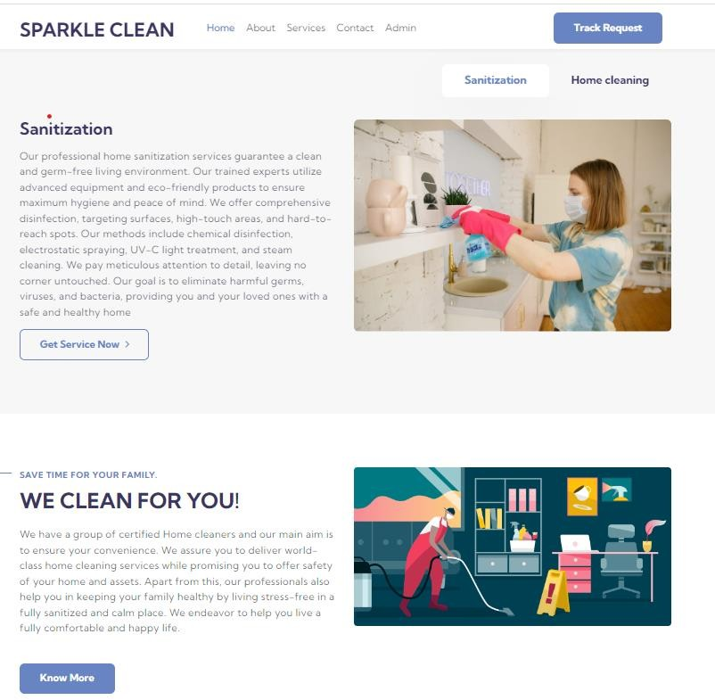

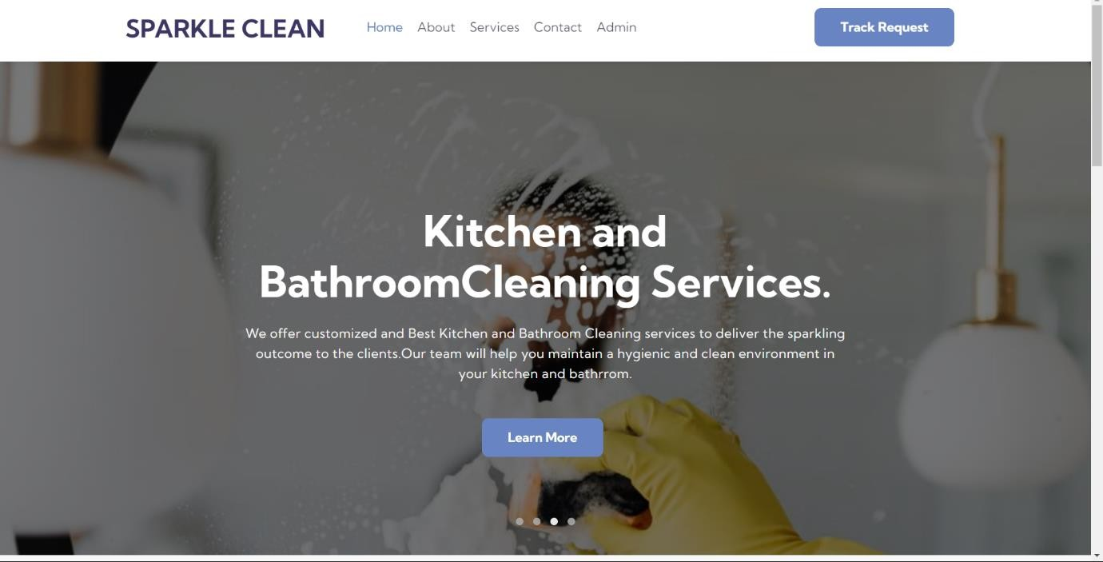

## About us page:

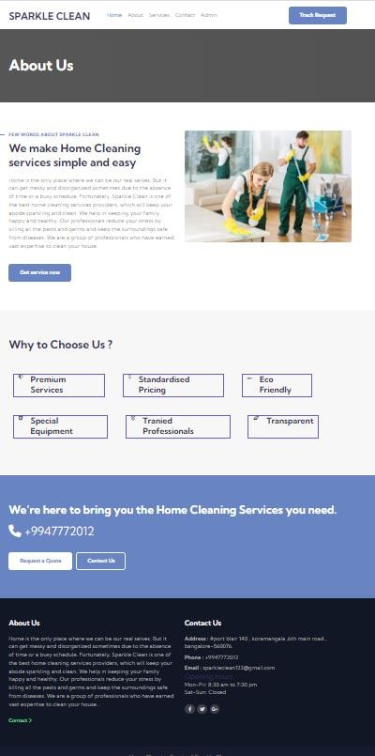

**Service page:**

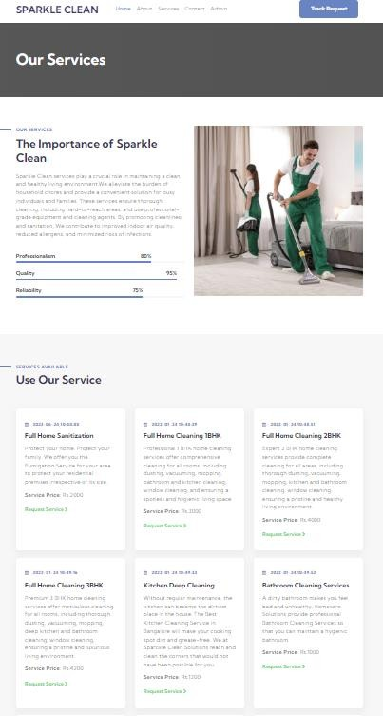

## Request form:

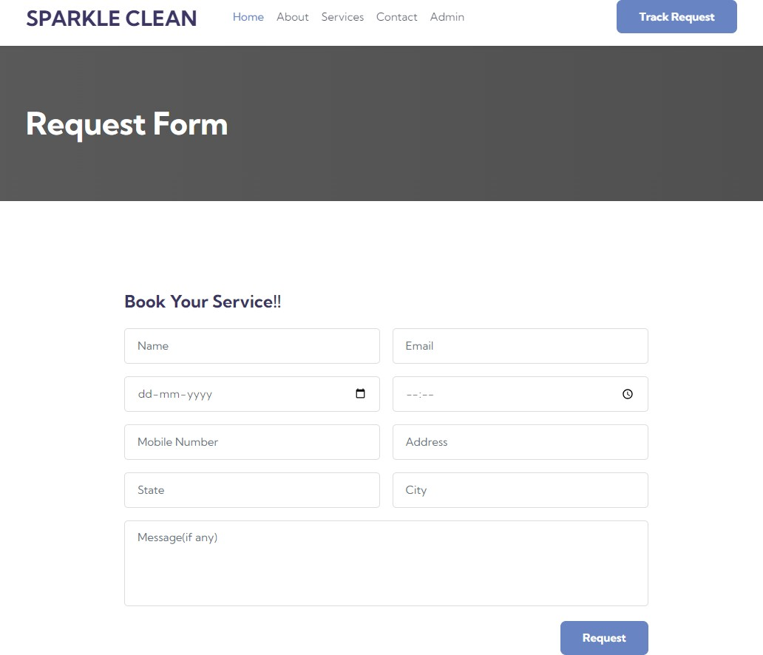

**Contact us page:**

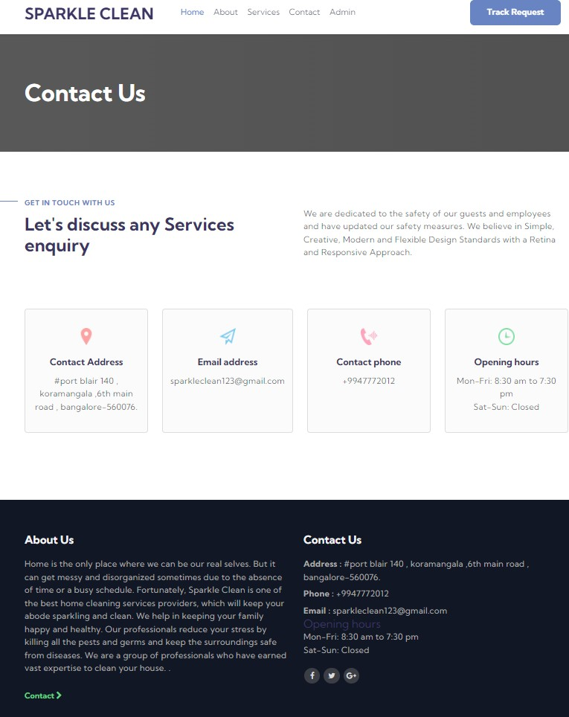

## Track Request:

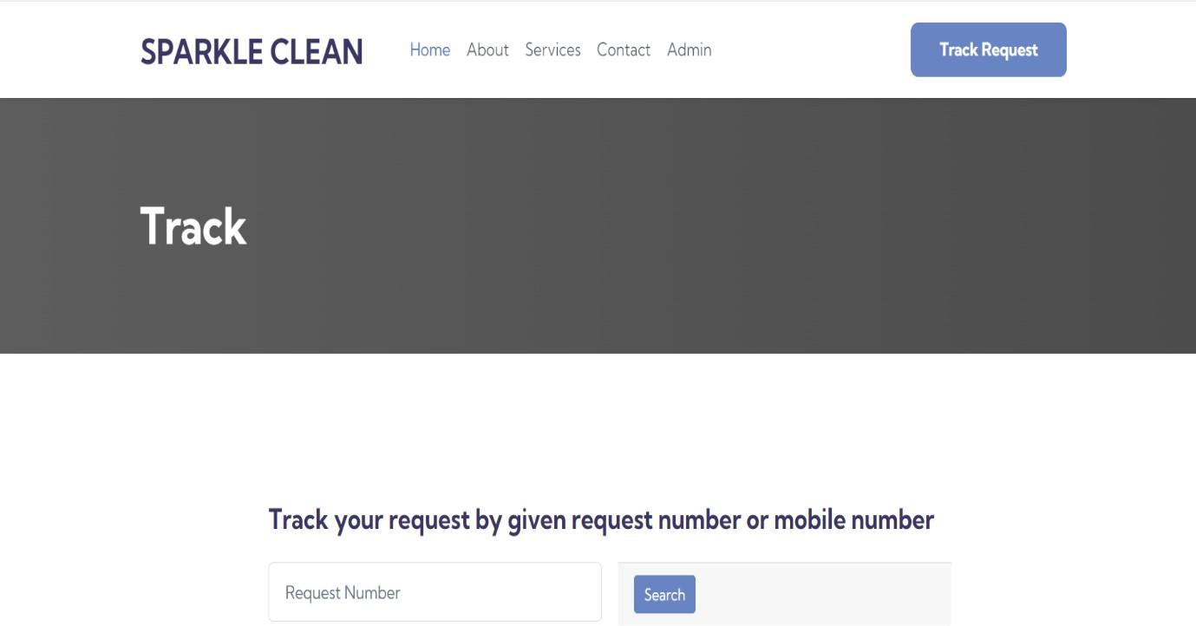

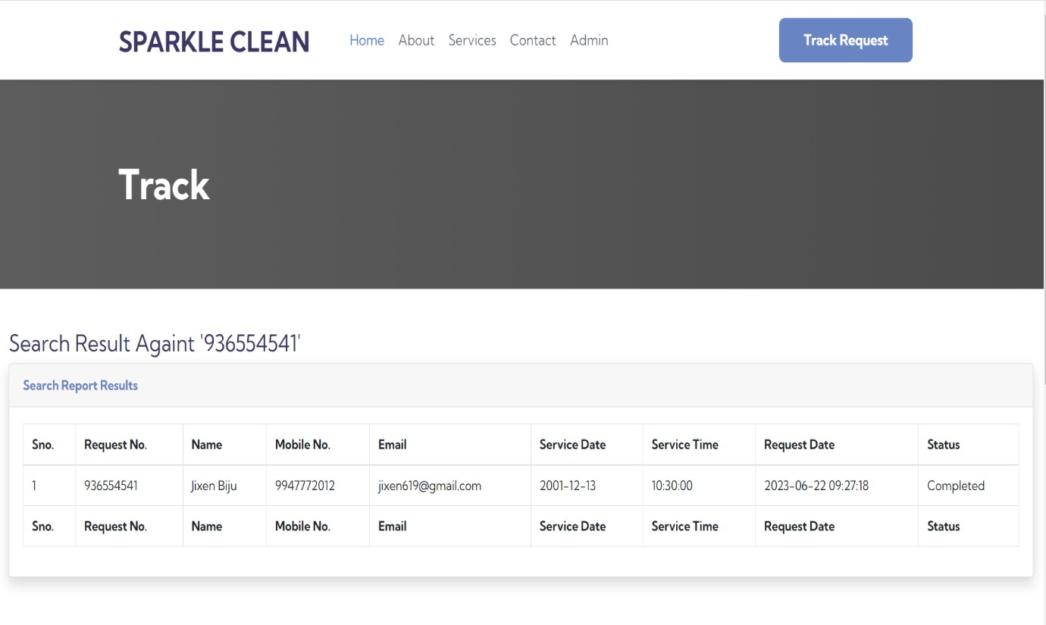

**ADMIN:**

## Admin login:

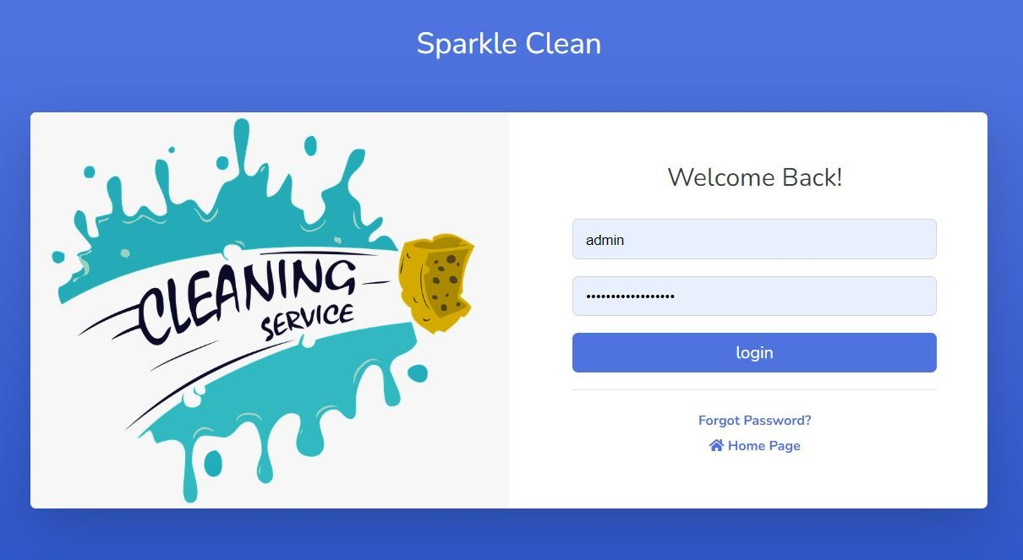

**Admin Logout:**

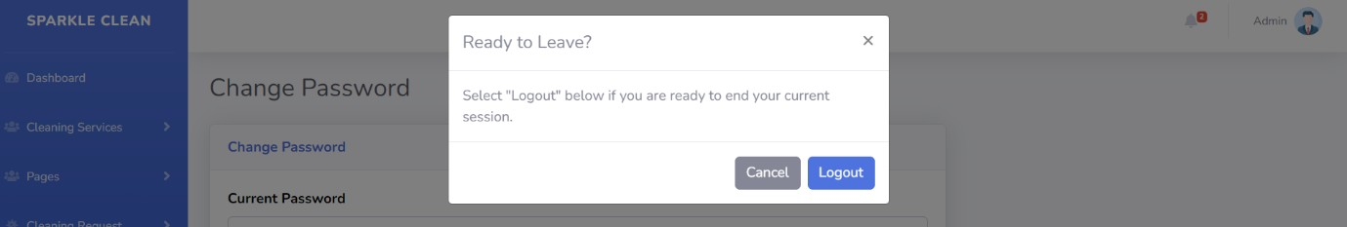

## Change Password:

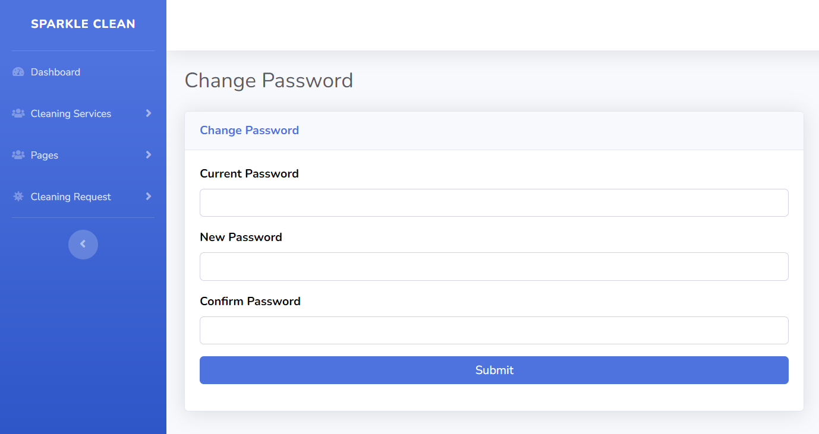

**Password Recovery:**

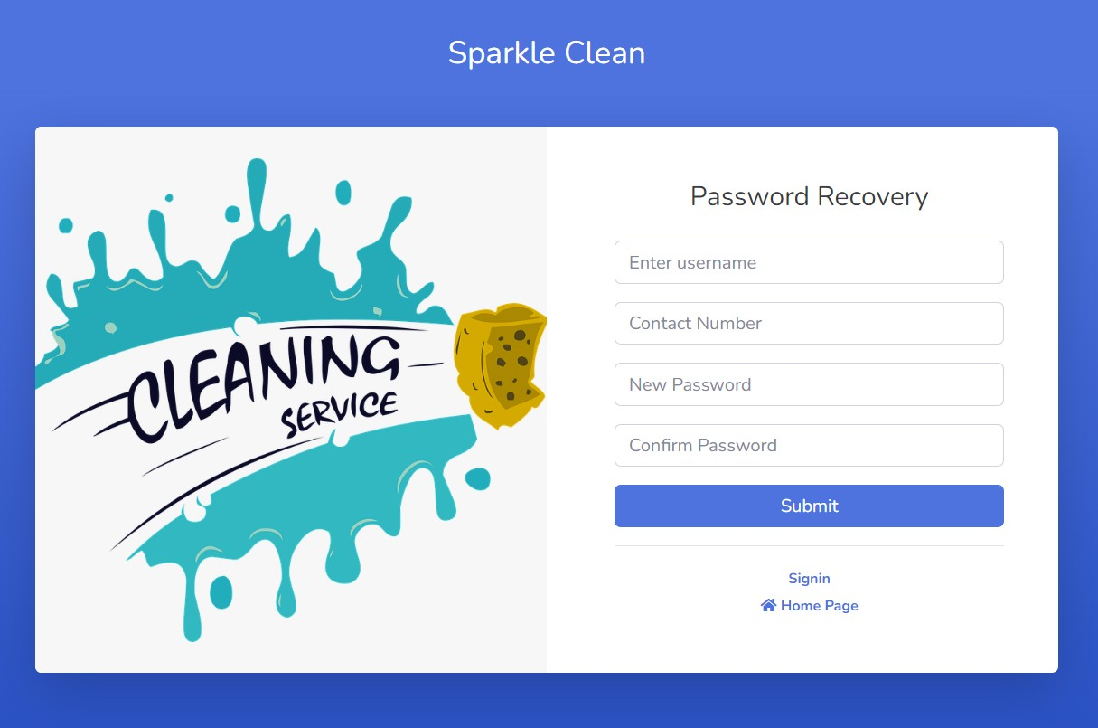

## Admin profile:



**Dashboard:**

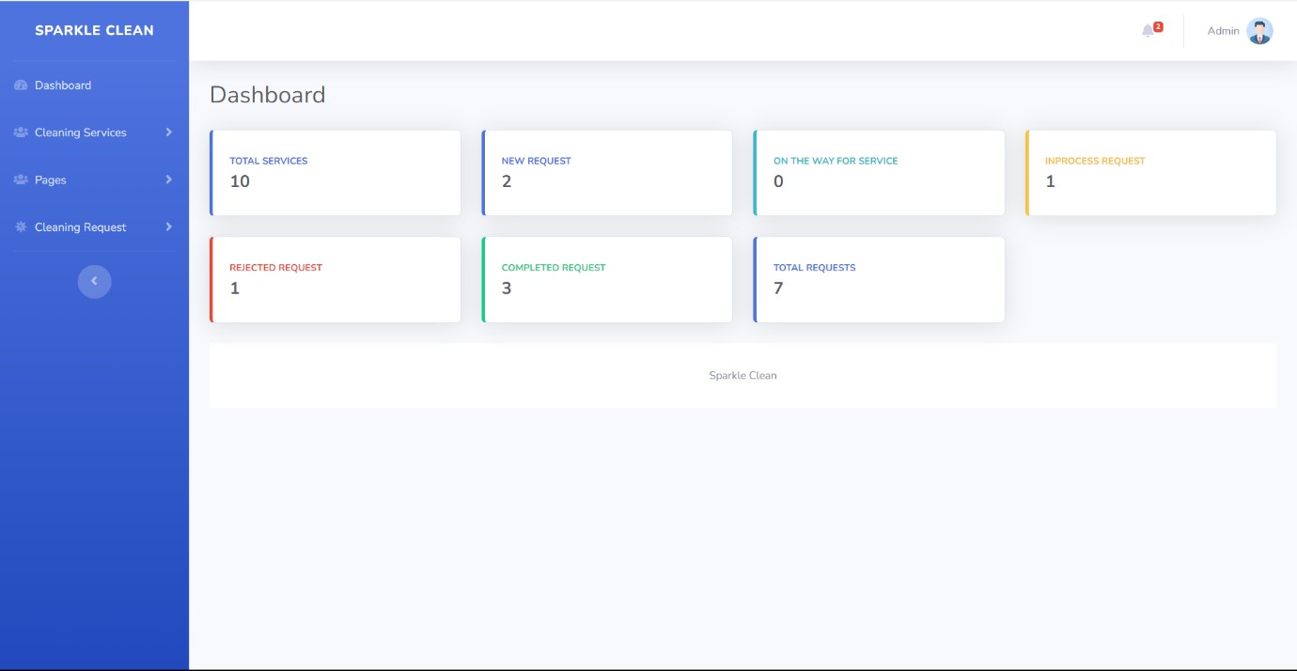

## Add service:

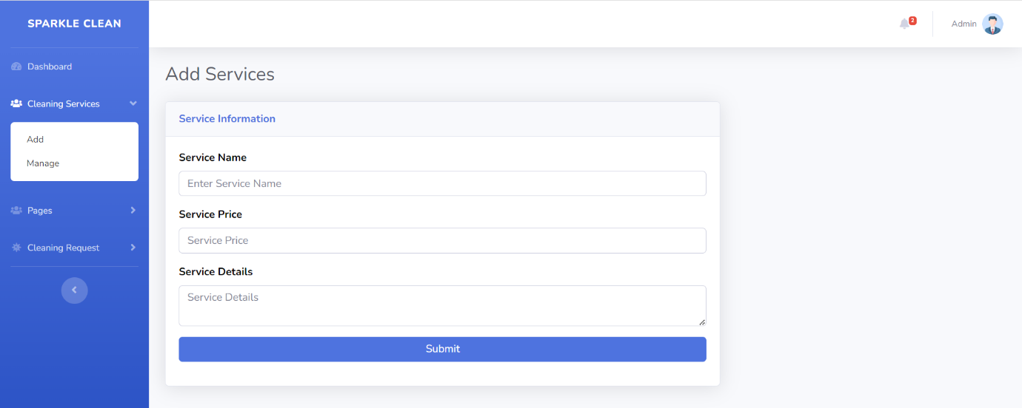

**Manage Service:**

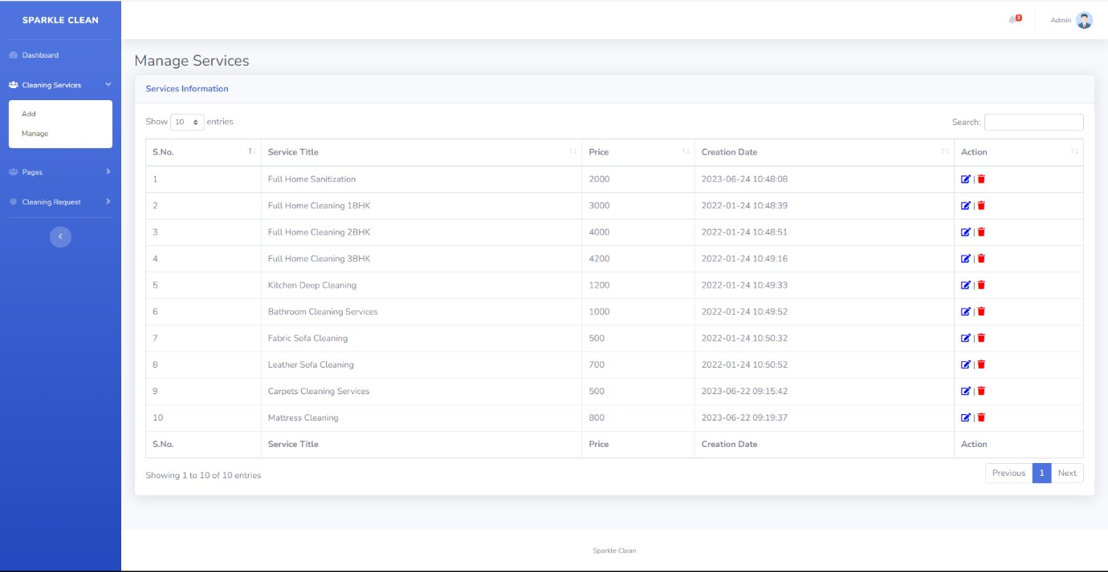

## Manage About Us Page:

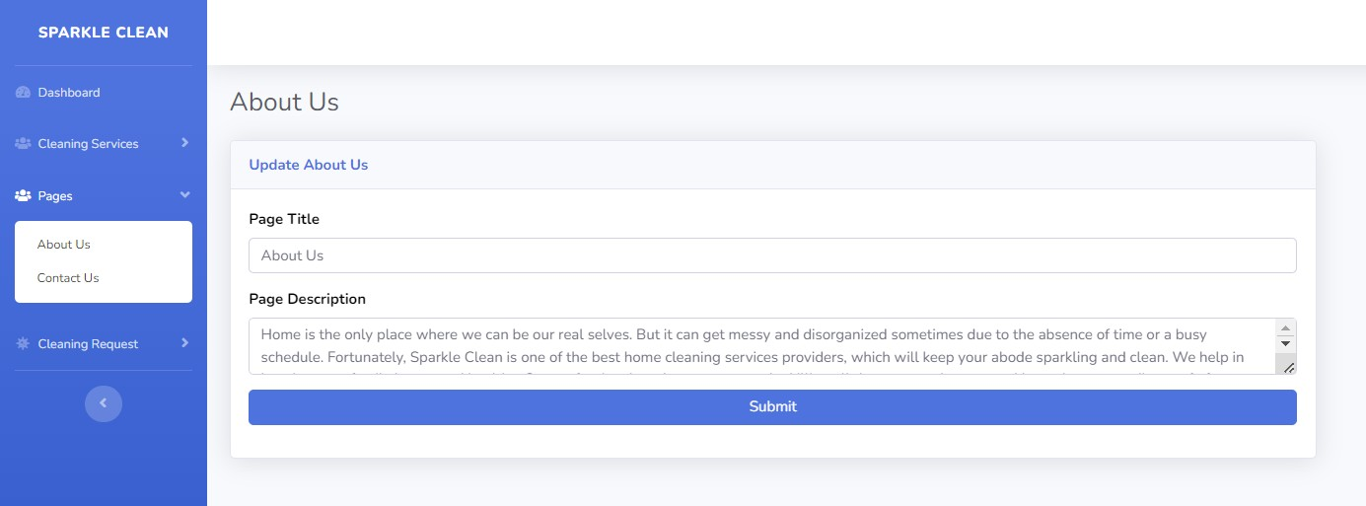

**Manage contact us page:**

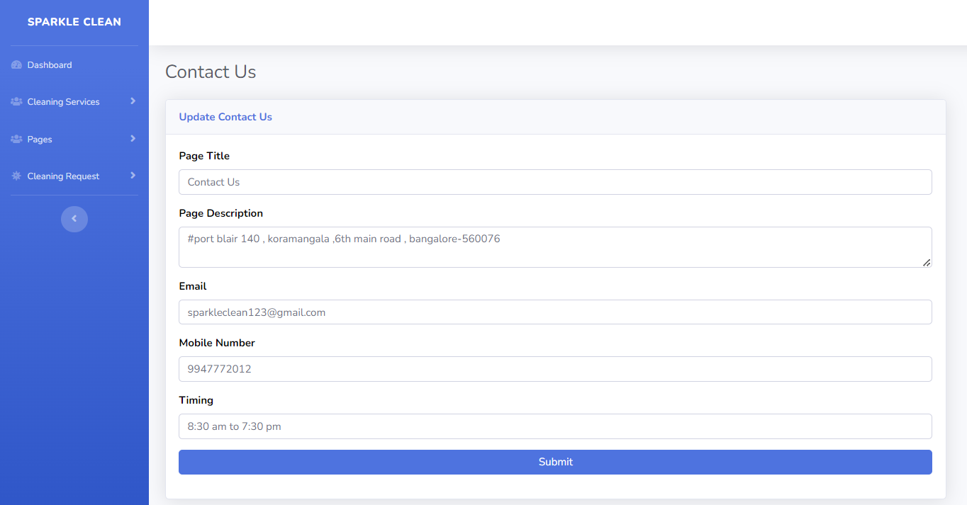

## New Request:

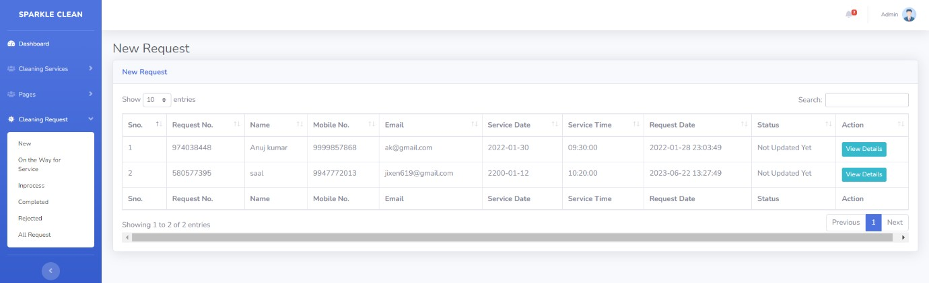

**On The Way Request:**

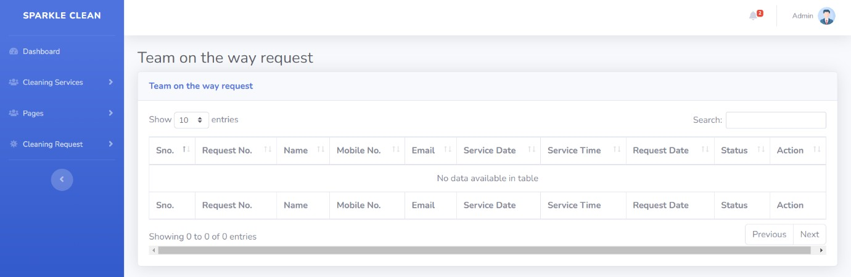

## In process Request:

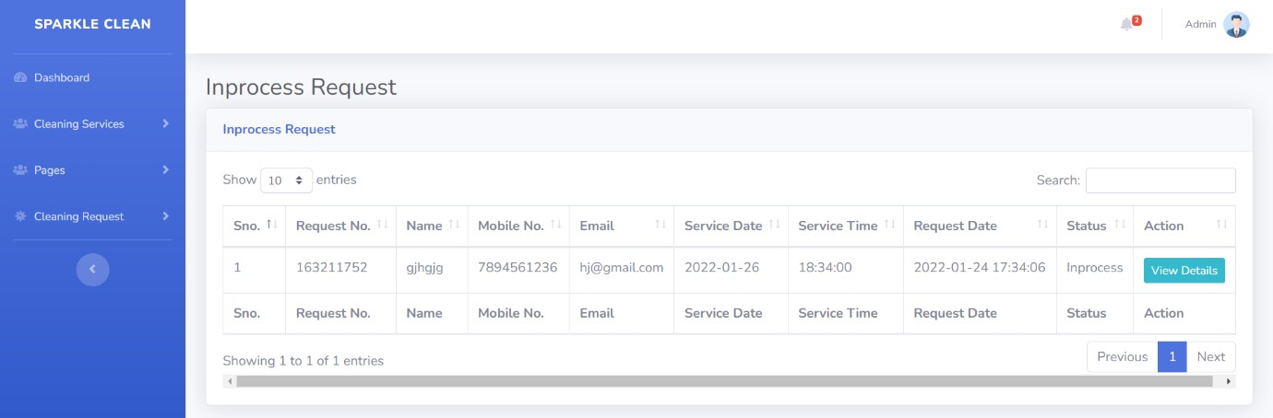

**Completed Service:**

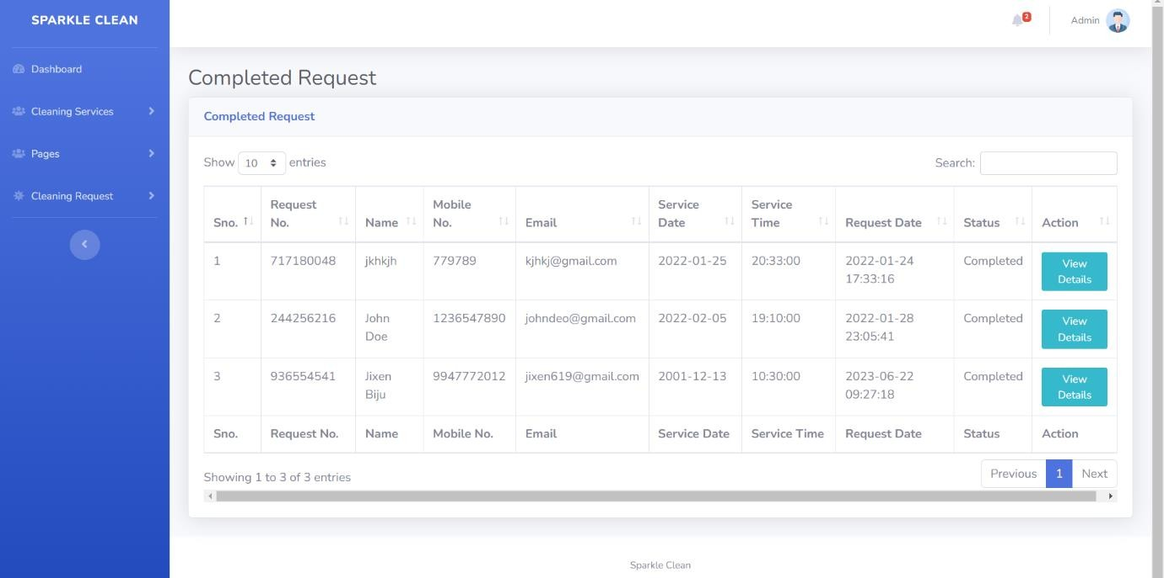

## Rejected Service:

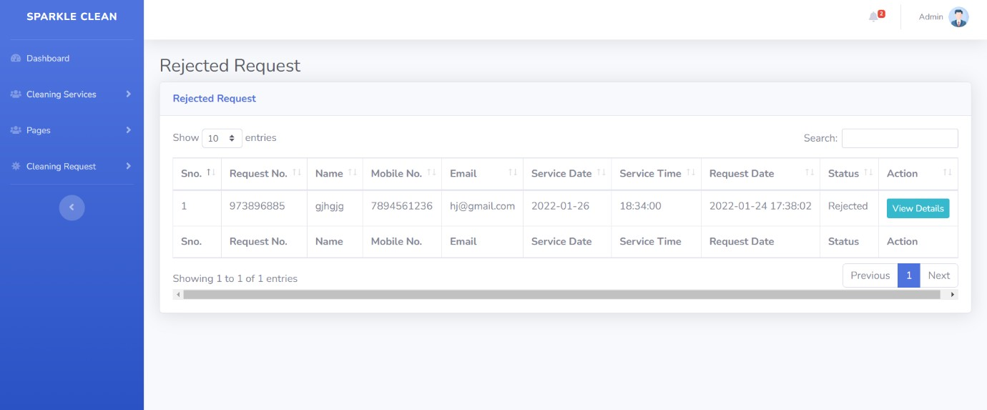

**All Request:**

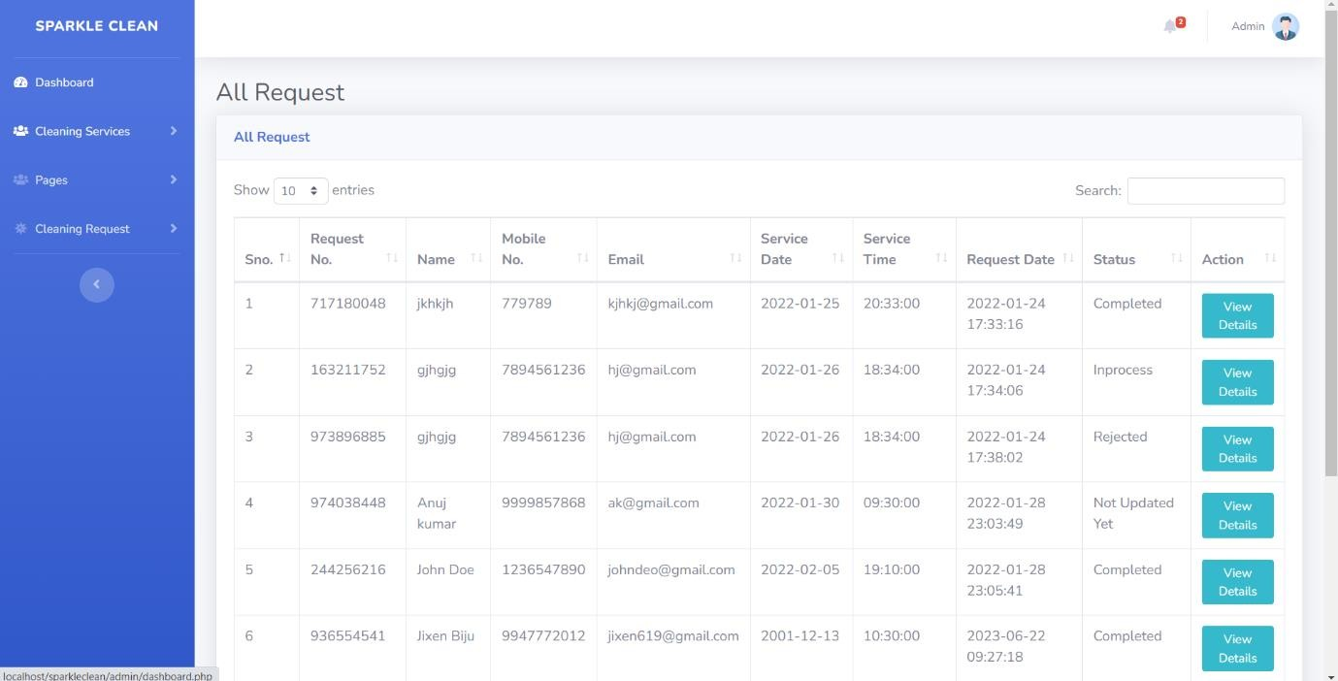

# TESTING

After all phases have been perfectly done, the system will be implemented to the server and the system can be used.

## System Testing (Unit testing, Integrity Testing)

After the completion of the design and coding phase the next stage in the development of a software project is a testing phase. Testing plays very critical role for quality assurance and for ensuring the reliability of software. During testing, the program to be tested is executed with a set of test cases, and the output of the program for the test cases is evaluated to determine if the program is performing as it is expected to. Unit testing is commenced when a unit has been created and effectively reviewed. In order to test a single module, we need to provide a complete environment i.e., besides the section we would require.

* The procedures belonging to other units that the unit under test calls.
* Nonlocal data structures that module accesses.
* A procedure to call the functions of the unit under test with appropriate parameters.

### Test for the admin module

**Testing admin login form:** This form is used for logging in of administrator of the system. In this form we enter the username and password if both are correct administration page will open otherwise if any of data is wrong it will get redirected back to the login page and again ask the details.

## Integration Testing

When an individual unit code testing is done there starts the Integration testing takes place. In this many tested modules are combined into sub systems, which are then tested. The goal here is to see if the modules can be integrated properly, the emphasis being on testing interfaces between modules. This testing activity can be considered as testing the design and emphasis on modules in interactions. When all the compilation is done then an overall application is done which checks one and every object coding, linking, etc and finally provides the results as the standard EXE. In the Integration testing we test various combination of the project module by providing the input.

The primary objective is to test the module interfaces in order to confirm that no errors are occurring when one module invokes the other module.

## Unit Testing

Unit testing is a dynamic method for verification where the program is compiled and executed. It is one of the most widely used methods. The goal of unit testing is to test modules or “units” and not the entire software system. In this part of testing the system coding is compiled for every individual form, classes, and modules. Every object present in the forms is coding part the appropriate code is written. To make the objects work properly the codes are compiled. After compilation if any error occurs it is rectified and made sure that every object in the form is working properly and according.

### Test Case 1: Login Module:

|  |  |  |  |  |
| --- | --- | --- | --- | --- |
| SL.NO | Description | Expected Result | Actual Result | Status |
| 1. | Invalid admin | User must login successfully | User logged in successfully | Pass |
| 2. | Valid admin | User must login successfully | System displayed an error message | Fail |
| 3. | Blank input  value | User must login successfully | System displayed an error message | Not Applicable |

* Invalid Admin

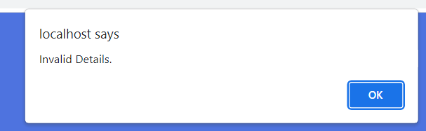

* Valid Admin

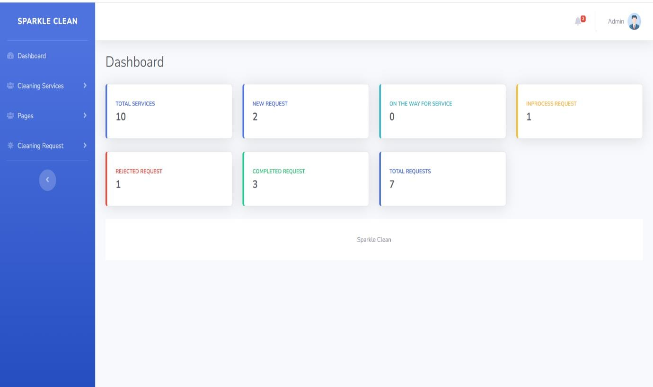

valid details will take the admin to the dashboard.

* Blank Input Values

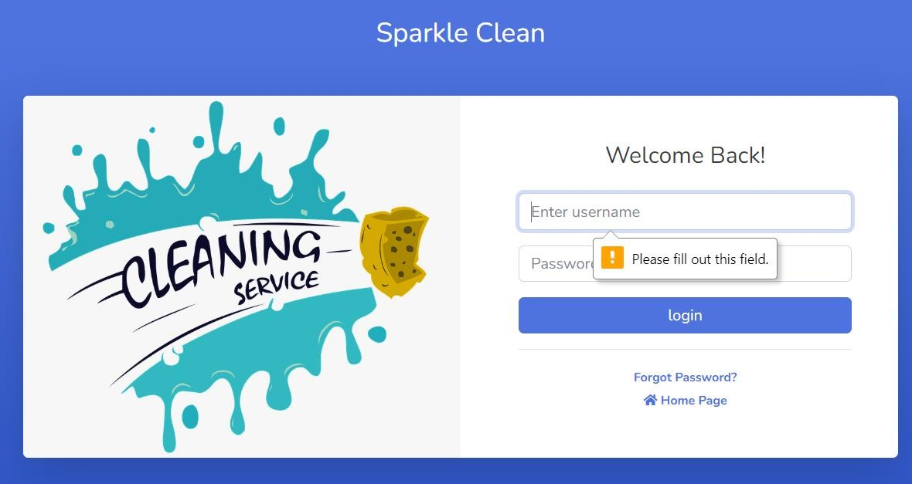

### Test Case 2: Service Booking Module

|  |  |  |  |  |
| --- | --- | --- | --- | --- |
| SL.NO | Description | Expected Result | Actual Result | Status |
| 1. | Valid Request | User must submit request successfully | Your request has been sent successfully | Pass |
| 2. | Invalid Request | User must submit request successfully | System displayed an error message | Fail |
| 3. | Blank input value | User must submit request successfully | System displayed an error message | Not Applicable |

* Invalid Request

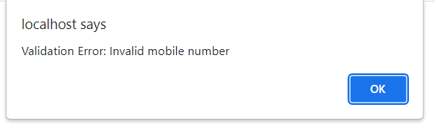

* Valid Request

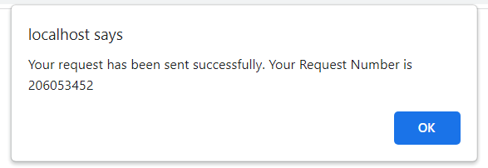

* Blank Input Value

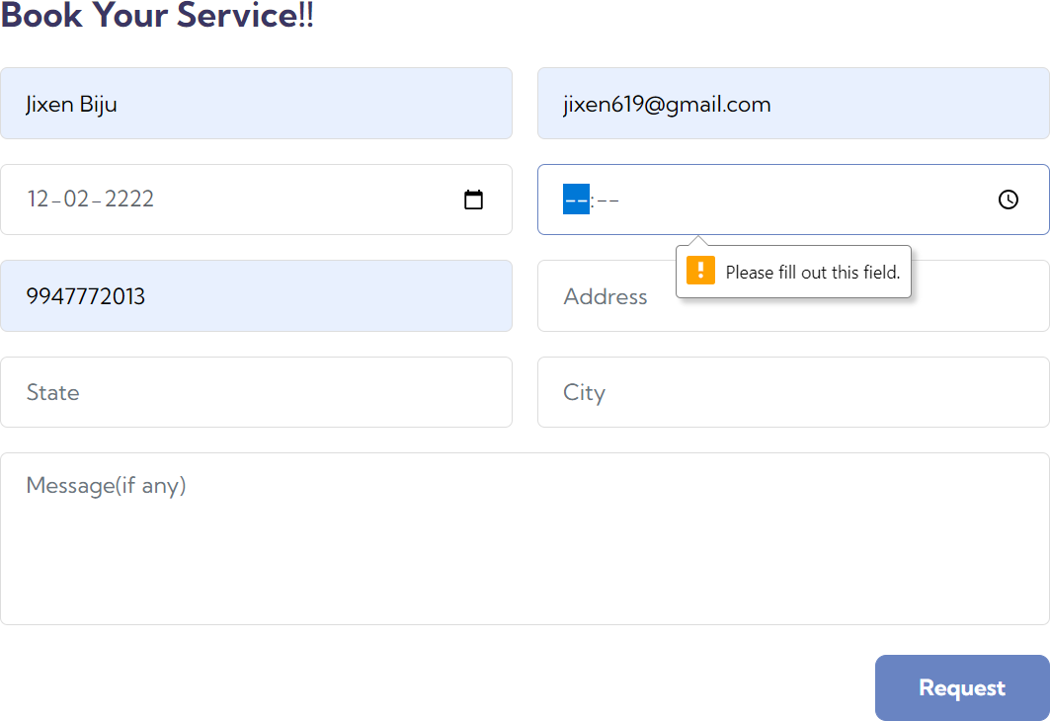

### Test Case 3: Service Manage Module

|  |  |  |  |  |
| --- | --- | --- | --- | --- |
| SL.NO | Description | Expected Result | Actual Result | Status |
| 1. | Add Service | Service details should be updated | Service details Has been updated  successfully | Pass |
| 2. | Blank input value | Service details should be updated | Field empty | Not Applicable |

* Add Service

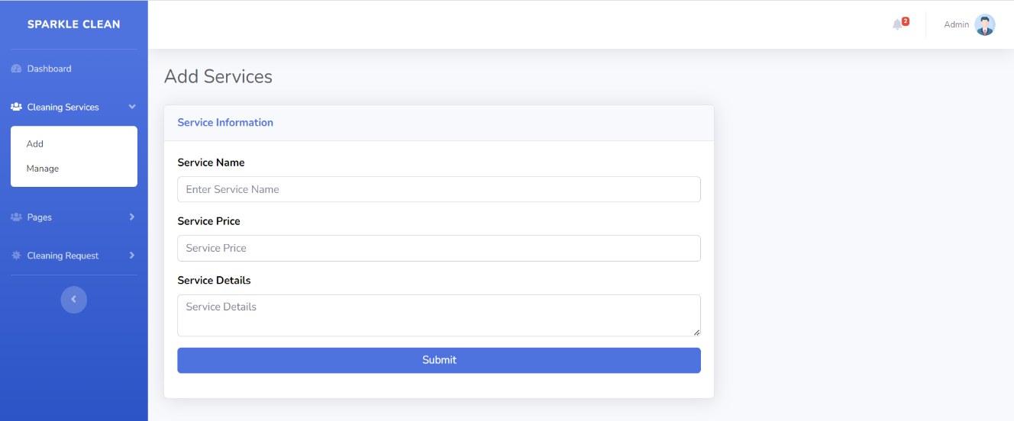

* Blank Input Value

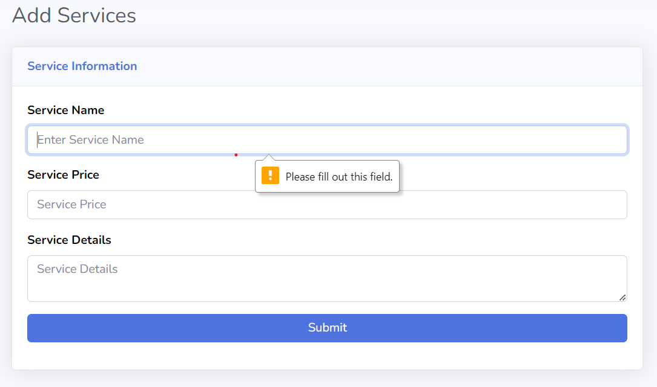

### Test Case 4: Pages Manage Module

|  |  |  |  |  |
| --- | --- | --- | --- | --- |
| SL.NO | Description | Expected Result | Actual Result | Status |
| 1. | Manage About  Us Page | About us details should be updates | Details updated  successfully | Pass |
| 2. | Manage Contact  Us Page | Contact Us details  Should me updated | Details updated  successfully | Pass |
| 3. | Blank input  value | Details should be updated | Field empty | Not Applicable |

* Add About us Page Details



* Add Contact us Page Details

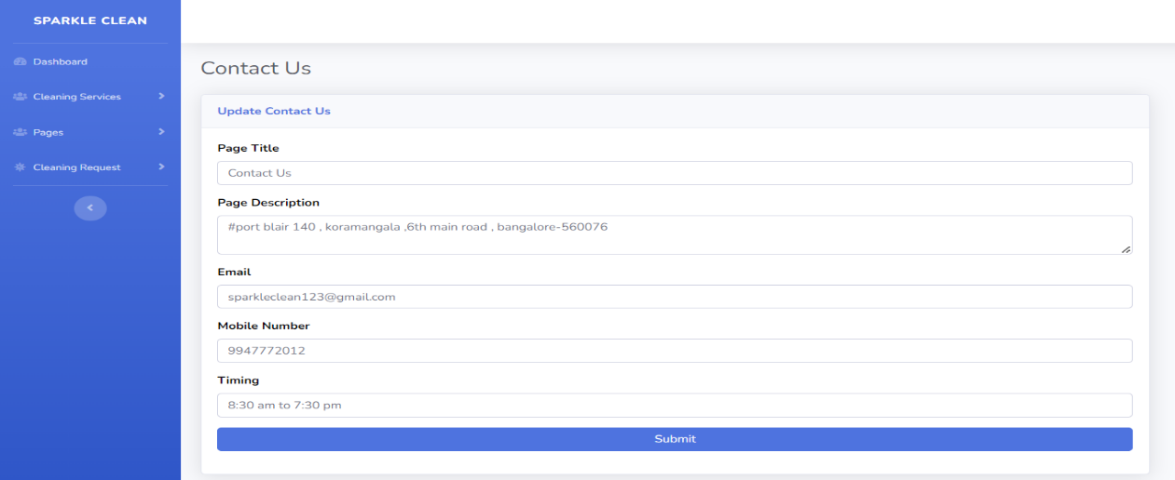

* Blank Input Value

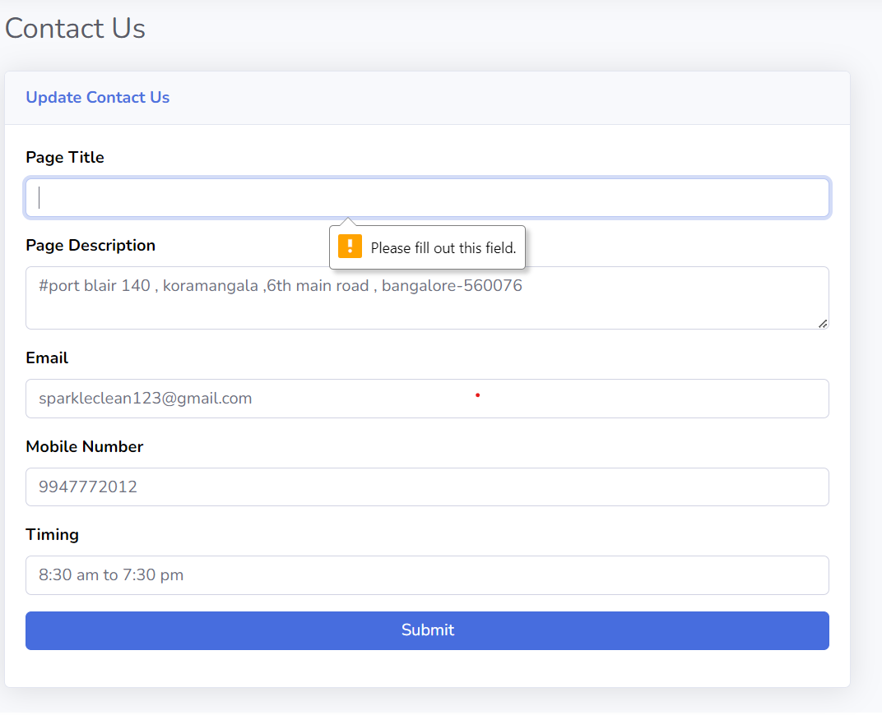

### Test Case 5:

**Admin profile Manage Module:**

|  |  |  |  |  |
| --- | --- | --- | --- | --- |
| SL.NO | Description | Expected Result | Actual Result | Status |
| 1. | Update Admin profile | Admin details should be updated | Admin details has  been updated successfully | Pass |
| 2. | Blank input value | Admin details should be updated | Field empty | Not Applicable |

* Update Admin Profile

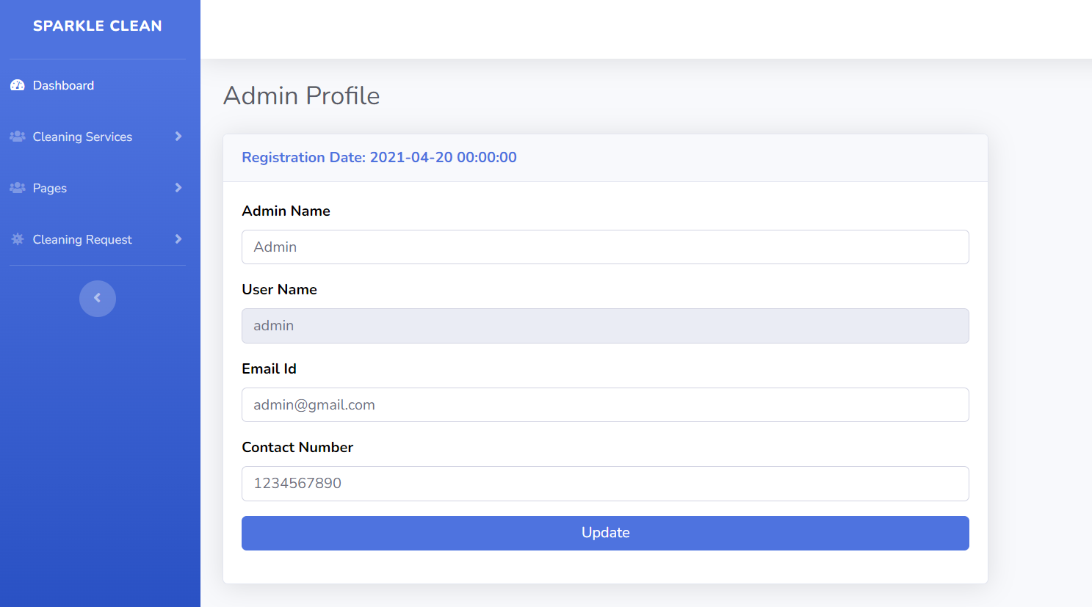

* Blank Input Value

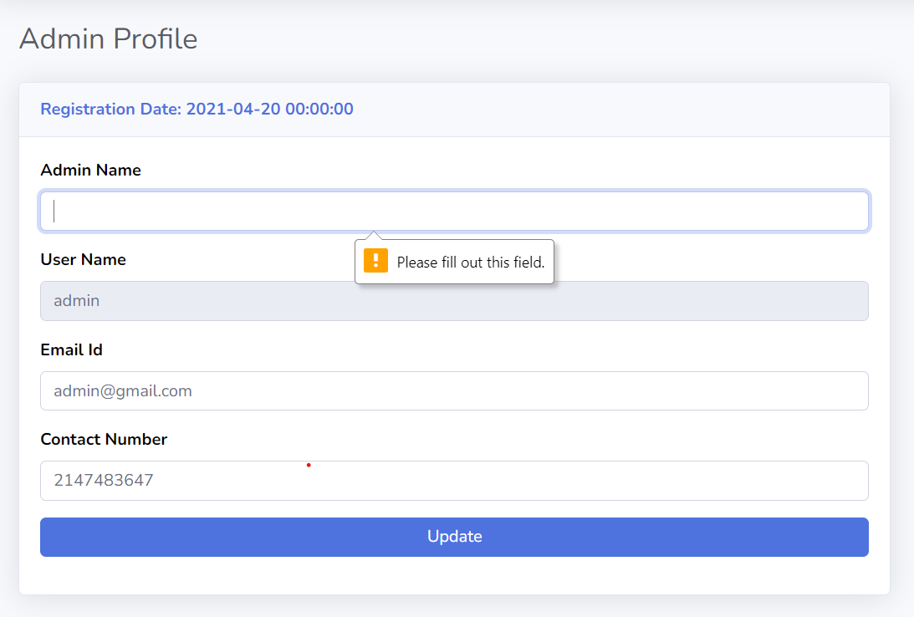

### Test Case 6:

**Admin password reset Module:**

|  |  |  |  |  |
| --- | --- | --- | --- | --- |
| SL.NO | Description | Expected Result | Actual Result | Status |
| 1. | Valid Request | Password must be  updated | Password Updated  Successfully | Pass |
| 2. | InValid Request | Password must be  updated | System displayed an error message | Fail |
| 3. | Blank input  value | Password must be  updated | System displayed an error message | Not Applicable |

* Incorrect Password

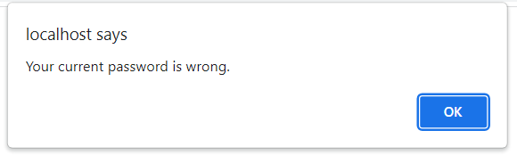

* Password not matching

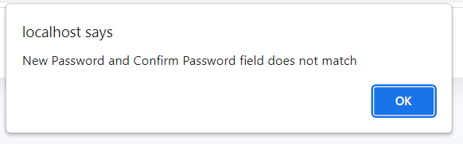

* Password successfully changed

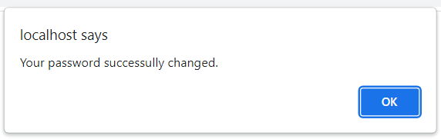

* Blank input value

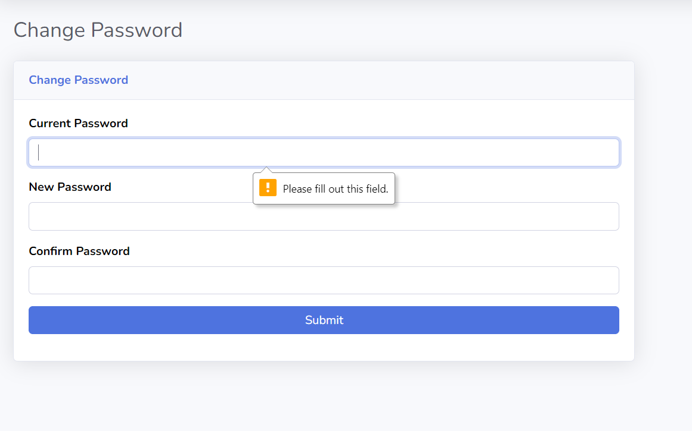

# CONCLUSION

This Project can be used by any cleaning service companies for keeping record of users. This project is easy, fast, and accurate. It requires less disk space. “Sparkle Clean” uses MYSQL Server as backend so there is not any chance of data loss or data security. It makes entire process online and can generate reports. The Application was designed in such a way that future changes can be done easily. The following conclusions can be deduced from the development of the project. The online cleaning services booking portal offers numerous benefits such as increased productivity, improved customer experience, enhanced communication, and data security. Its ease of use, scalability, and future modification capabilities make it a valuable tool for cleaning service companies to streamline their operations and provide a seamless booking experience for their customers. The project has been designed with flexibility in mind, allowing for future modifications and enhancements. As the cleaning service industry evolves and customer demands change, the portal can be easily updated and customized to meet new requirements. This adaptability ensures that the portal remains relevant and effective in the long run. By using MYSQL Server as the backend, the project ensures a high level of system and data security. MYSQL Server is known for its reliability and robust security measures. This provides peace of mind to both the cleaning service company and its customers, knowing that their data is safe and protected. The portal allows for easy updating of information. Whether it's customer details, service availability, or pricing, staff can quickly and accurately update the system. This ensures that the information available to customers is always up to date, minimizing confusion and errors

* Automation of the entire system improves the productivity.
* It provides a friendly graphical user interface which proves to be better when compared to the existing system.
* It gives appropriate access to the authorized users depending on their permissions.
* It effectively overcomes the delay in communications.
* Updating of information becomes so easier.
* System security, data security and reliability are the striking features.

# FUTURE ENHANCEMENT

1. **Ratings and Reviews:** Allow users to rate and leave reviews for the cleaning services they have booked. This feature can help other users make informed decisions when selecting services.
2. **Service Customization:** Provide options for users to customize their cleaning service based on their specific requirements. For example, users can select additional cleaning tasks or choose specific cleaning products.
3. **Real-Time Availability:** Implement a real-time availability system that shows users the available time slots for each service. This can help users book services conveniently
4. **Multiple Locations**: Allow users to select their preferred location for the cleaning service. Provide a list of service areas or implement a geolocation feature to determine service availability in different regions.
5. **Subscription Plans**: Offer subscription plans for regular cleaning services. Users can subscribe to a weekly, bi-weekly, or monthly cleaning plan, providing them with discounts and regular cleaning schedules.
6. **Mobile Application:** Develop a mobile application for the booking portal, providing users with a convenient way to book services, manage bookings, and receive notifications.
7. **Live Chat Support**: Integrate a live chat feature to provide real-time assistance to users. This can help address any queries or concerns they may have during the booking process.
8. **Service Provider Profiles:** Create profiles for service providers, including information about their experience, certifications, and customer reviews. This can help users choose the right service provider based on their preferences.
9. **Social Media Integration:** Enable users to share their booked services or reviews on social media platforms. Integrating social media sharing buttons can help generate more visibility and attract new users.
10. **Multilingual Support:** Provide language options for users who prefer to use the booking portal in their native language. This can help expand the user base and improve user satisfaction.

# REFERENCES

### For PHP

* https://[www.w3schools.com/php/default.asp](http://www.w3schools.com/php/default.asp)
* https://[www.sitepoint.com/php/](http://www.sitepoint.com/php/)
* <https://www.php.net/>

### For MySQL

* https://[www.mysql.com/](http://www.mysql.com/)
* [http://www.mysqltutorial.org](http://www.mysqltutorial.org/)

### For XAMPP

* https://[www.apachefriends.org/download.htm](http://www.apachefriends.org/download.htm)